

Report on Joint activity with Healthwatch Sefton and Older People’s Forums.
Care for older people. 2017

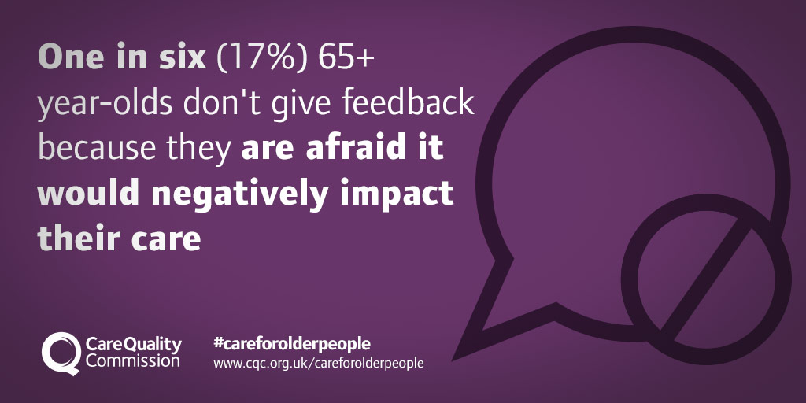
The Care Quality Commission (CQC) launched a campaign to encourage older people and their loved ones to feedback about the quality of health and social care they have received. Research has shown that older people are less likely to complain about services and less aware of the different ways they can share their views. Older people are the most regular users of health services. Two out of three people admitted to hospital and 70 per cent of hospital emergency beds are taken by those aged 65 and over. It's vital that the voices of our growing elderly population are heard.

In support of this Healthwatch worked in partnership with Sefton Pensioners Advocacy Centre – Older Persons Forums throughout Sefton – involving 165 older people from 5 Forums: Southport, Bootle, Crosby, Maghull & Formby .

Sefton’s Unique Position.

• Sefton has the highest proportion of residents aged 65+ and 75+ of all metropolitan boroughs in England.
• Sefton’s 50+ population is 41.5% of its total population – much higher than the average for England and for the North West.
• There are 28,400 people in the 75+ age group of whom about half live alone. This is projected to increase as a percentage of the total population and in actual numbers.
• These statistics are highlighted in the Sefton Health and Wellbeing Strategy and give rise to specific concerns about related issues such as the number of older carers and people with depression and dementia in our communities, and inequalities across the borough.
• The growth in the number of older citizens in Sefton presents great challenges in terms of its impact on health and social care services, but it also opens up real opportunities to build upon the knowledge, wisdom and contributions of older people in helping to make Sefton a more cohesive community, and one which is a great place in which to live and work.
(http://www.cpa.org.uk/cpa-lga-evidence/Sefton_MBC/SeftonStrategyforOlderCitizens2014-2019.pdf)

Our Aims

- To encourage older people to feedback on their care.
- To raise awareness of how important it is for older people and their loved ones to feedback on care for older people.

What we did.

- Healthwatch Sefton Engagement & Participation Officer, Betty Boner and Brian Clark , Locality Representative attended each Forum with a view to raising awareness of the CQC Campaign and to encourage older people to feedback their experiences of Registered Services.
- Healthwatch Sefton delivered a presentation at each Forum explaining about the role of Healthwatch and how experiences could be recorded on-line (www.healthwatchsefton.co.uk) or via Feedback forms which are available across the Borough, including the Older People’s forum meetings.
- An explanation was also given about the ‘Enter & View’ process whereby Healthwatch members gain face to face feedback from users of health and social care services.
- There were discussions about the CQC campaign and about the reasons why older people may be reluctant to come forward and share experiences. It was also mentioned that older people might feel they are making themselves more vulnerable by complaining about services particularly domiciliary care.

Feedback

- Forum members sharing that they had a better understanding of what Healthwatch Sefton can achieve.
- A key message shared that feedback to Healthwatch can be anonymous led forum members to report that they would have more confidence to report an experience in the future without fearing repercussions from service providers.
- Some Forum members highlighted issues around accessing appointments for Podiatry which Healthwatch Sefton is now reviewing. It has been agreed that Healthwatch Sefton will carry out further consultation at Podiatry clinics with patients, visitors and staff
- Feedback from the forums stated that, hearing the changes that Healthwatch had managed to achieve in Sefton has given the Forum members a very positive impression and they are now more likely to engage with Healthwatch in the future.

Healthwatch Sefton continues to work closely with Sefton Pensioners’ Advocacy Centre encouraging people to share health & social care experiences good or bad.
