

Aintree University Hospital NHS
Foundation Trust

Enter & View Report
Contact Details:  Staff contact for visit:  Date and time of visits &  Healthwatch Sefton Authorised Representatives: | Aintree University Hospital NHS Foundation Trust  Lower Lane  Fazakerley  Liverpool  L9 7AL  Beth Baines (Matron)  07/06/2016 2pm – 3.30pm  Wendy Andersen (Lead E & V Representative)  Maurice Byrne (E & V Representative)  Diane Foulston (E & V Representative)  Ken Lowe (E & V Representative)  06/07/2016 1.30pm – 4pm  Wendy Andersen (Lead E & V Representative)  Betty Boner (E & V Representative)  Brian Clark (E & V Representative)  Ken Lowe (E & V Representative)  Nigel Smith (E & V Representative)

Contents
Heading | Page No.
Introduction | 3-4
Aintree University Hospital NHS Foundation Trust | 4
Acknowledgements | 5
Methodology | 5
Summary of main findings | 5-6
General results | 6-8
Ward 30 | 9-13
Ward 31 | 14-18
Ward 32 | 19-23
Ward 33 | 24-28
Ward 34 | 33-34
Conclusion | 34-35
Response from Aintree University Hospital NHS Foundation Trust | 35-37
Appendix 1 – Questionnaire | 38-41
Appendix 2 – Aintree University Hospital NHS Foundation Trust – feedback following Enter & View visit | 42-43

Introduction
This was an announced Enter & View visit undertaken by authorised representatives from Healthwatch Sefton who have the authority to enter health and social care premises, announced or unannounced, to observe and assess the nature and quality of services and obtain the views of those people using the service.
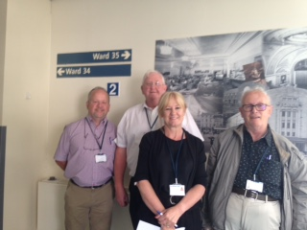

The Enter & View visit(s) were arranged due to 2 previous experiences received in August 2015 in relation to the blue reclining chairs next to patients’ beds being removed and replaced with chairs that had wooden arms and legs. Concerns were raised over patient comfort and safety. At this time Aintree University Hospital Foundation Trust (Aintree hospital) responded to say:
‘Although the new chairs with the integrated pressure relieving cushions are at patient bedsides, the reclining chairs are stored on the wards and are still available for patient use. Patients and relatives can choose to request the recliners, but where possible we are asking patients to use the new chairs due to the benefits of the integrated pressure reducing cushion which will lesson the risk of the patient developing a pressure ulcer and allow them to sit out of bed for longer period of time’.
In March 2016 at Aintree Hospital’s Patient Experience Executive Led group meeting a patient experience was shared by the Trust highlighting that a patient had been sat on a high backed chair on ward 33 which was tilted and the patient had difficulty getting out of it safely.
As a Healthwatch we are aware of the reduction in pressure ulcers that Aintree hospital has achieved on grade 2’s by 8.7% through the recent Quality Accounts.
Two Enter & View visits were planned to gather experiences from patients and their visitors on aspects of patient care including comfort. The wards chosen were the Rehabilitation wards and Frailty Ward at the Trust. The visits were carried out on two separate days.
A set questionnaire was used to gather the views and experiences and the feedback and observations are contained within this report. In the first instance this report will be sent to the Director of Nursing and Quality at the Trust for validation of the facts. Any response from the Director of Nursing and Quality is included in the final version of the report which will be published on the Healthwatch Sefton website at www.healthwatchsefton.co.uk
Aintree University Hospital NHS Foundation Trust
Aintree University Hospital NHS Foundation Trust provides general acute health care to 330,000 residents in North Merseyside and surrounding areas. It also works with partners to provide a range of services in community settings including rheumatology, ophthalmology and alcohol services.
Aintree’s Major capital project is a £35m Urgent Care and Trauma development, which is creating state-of-the-art Emergency Department, major trauma, critical care and cardiology facilities, among other services for the region’s most seriously-ill patients.
Aintree is a teaching hospital of the University of Liverpool and a tertiary centre providing specialist services to around 1.5m residents in Merseyside, Cheshire, South Lancashire, North Wales and the Isle of Man. Tertiary services include Respiratory Medicine, Rheumatology, Maxillofacial and Liver Surgery, all of which have world-class reputations. http://www.aintreehospital.nhs.uk/about-us/ 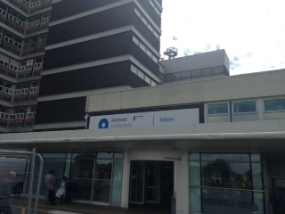
Acknowledgements
Healthwatch Sefton would like to thank Nicola Firth, Director of Nursing and Quality and June Taft, Corporate Assistant Director of Nursing Services for working with Healthwatch Sefton in organising the visits. Healthwatch Sefton would also like to thank Beth Baines, Matron along with the staff, patients and visitors for welcoming us and taking part in the visit.

Methodology
The Enter & View team visited Aintree hospital on Tuesday 7th June and Wednesday 6th July 2016.
The team spoke to 33 patients / family and visitors. A questionnaire was used covering 6 themes (Cleanliness, Care & Treatment, Nutrition & Hydration, Safety, Environment and Kindness, Dignity & Respect). This was designed to gather patient, family and visitors overall experience of patient care and comfort whilst at Aintree hospital. (Appendix 1 Questionnaire).

Summary of main findings

- Patient bedside chair - 20 of the 33 respondents when spoken to said they were not aware they had a choice of patient bedside chair. 9 said they were aware. 4 stated they did not know or N/A.

- Patient bedside chair - Comments were received from both respondents and staff relating to the new high back chairs being un-comfortable for patients, including not being able to adjust the chairs for patient height and comfort and pillows being used to aid comfort.

- Cleanliness - All respondents stated the ward was clean with 25 stating the patient toilet area was clean. Respondents who stated they did not know if the patient toilet area was clean were visitors or did not use the patient toilet.

- Staff attitude - A high number of comments related to staff being approachable and being able to answer patient /visitor questions well enough.

- Day room - Although each ward had a day room the findings from this report showed patients were mainly either unaware of the day room or had been unable to use it.

- Access to TV - each bay was fitted with one TV therefore not accessible by all patients and none of the TV’s displayed subtitles.

- Hospital patient information folder - There is differing findings between the ward bays having the patient folders next to patient besides.

- Ward 32 – it was reported that 3 patients did not have dentures or experienced problems with dentures with two respondents stating the hospital had lost them. This caused problems at meal times.

- Ward 34 Patient hearing aid – An issue was highlighted by family members that the hospital had lost the patients hearing aid in March 2016 and the patient still did not have a hearing aid. Healthwatch Sefton reported this to PALS and the Director of Nursing on the day and the situation was dealt with promptly by the Trust.

General results
Please see below the results from the general questions that were asked on the questionnaire including:
- Patient Age - Patient ages ranged from 57 years old to 96 years old.

- Patient Sex – There were 14 females, 18 males and 1 patient sex not recorded.

- Date of admission / length of stay – Patients stay ranged from a few days to 3 months. The results are based on the answers given by patient, relatives and visitors therefore may not be accurate. Please see graph below:

- Time of visit – Both Enter & View visits were carried out during the afternoon and coincided with visiting times on each ward to ensure a mixture of views were recorded.

- Wards – The Enter & View visits were carried out on the Rehabilitation wards and Frailty Ward. This included wards 30,31,32,33 and 34. In total there were 33 completed questionnaires. A breakdown of how many questionnaires were completed on each ward is shown in the below graph:

- Who did you speak with (patient, family, friend)
Please see the below graph for the breakdown on who was spoken to during the Enter & View visits:

Enter & View Questionnaire results and observations
Due to the Enter & View visits spanning over 2 separate visits and 5 wards this report has been split into each ward separately to ensure any specific findings relate directly to the ward.

Ward 30
Enter & View representation on this ward was four Enter & View representatives working in pairs to complete a set questionnaire. Observations were also carried out.
Completed Questionnaire responses:
In total there were 7 completed questionnaires on ward 30. Please note 1 respondent only answered questions at the start and was unable to continue with the questionnaire. The respondent answers have therefore been recorded as not answered.
Please see below for the themed responses.

Cleanliness
All 6 respondents stated that the ward was clean and the patient toilet area was clean. 5 respondents stated that they are offered hand wipes / hand washing prior to mealtimes / after using toilet, 2 respondents did not answer.

Care & Treatment
All 6 respondents stated they felt the staff were approachable with 1 respondent adding that the odd one was not. 5 of the 6 respondents felt staff answered their questions well enough. 5 respondents stated they were made to feel comfortable during the day with 1 stating they were too hot. 3 of the 6 respondents stated they were not aware that they had a choice of chair to sit in.
There was a mixed response to how long patients sat in their chair but mainly respondents referred to long periods. All 6 respondents stated they had confidence in the staff treating them. 2 of the 6 respondents stated there was no hospital information folder next to their bed. 4 of the 6 respondents said they could request a bath or shower whenever they felt they needed one with 2 stating they did not know.

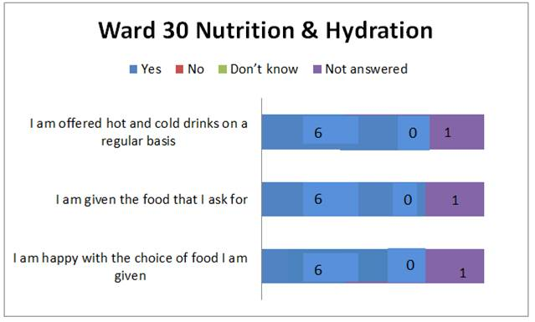
Nutrition & Hydration
All 6 respondents stated they were happy with the choice of food given.
All 6 respondents stated they were given the food they asked for and were offered hot and cold drinks on a regular basis.

Safety
All 6 respondents said they felt safe on the ward and that their emergency buzzer was in easy reach. When asked if they pressed their buzzer were they seen to quickly enough 2 respondents stated yes and 4 respondents stated they did not know or not applicable as had not needed to use it.

Environment
3 of the 6 respondents were not aware that the ward had a day room. 3 of the 6 respondents stated the room temperature was too hot / warm with 1 respondent stating it was too cold. 4 of the 6 respondents felt they had good access to a TV. When asked if they were disturbed at night 2 of the 6 respondents stated they were, 1 stating it was from too much noise and lights.

Kindness, Dignity & Respect
All 6 respondents stated they were spoken to by their preferred name with 5 stating they were aware of the nurse caring for them that day. All 6 respondents felt their privacy & dignity was always maintained and that they were treated with kindness during the day.
Ward Observations by Enter & View Representatives
 | Ward 30 | Day Room
RAG boards | Rag rating and visitor information well displayed.
Patient Information Boards | Individual boards checked appeared to be completed. | No observations recorded
Dementia Friendly | Visible effort to be dementia friendly, but flooring between bays and corridors was a problem.
Environment | The bays and rooms clean.  Member of staff stated they still had the blue reclining chairs and they had been reupholstered with the ulcer pressure relieving cushions. It was stated one of the problems with the new chairs was not being able to adjust them e.g if a patient was small and their feet could not reach the floor this could cause pins & needles. | Pleasant and open to outside area. Staff commented they do not have enough staff to operate both the bays and day room. Day room appeared under used.

Ward 31
Enter & View representation on this ward was four Enter & View representatives working in pairs to complete a set questionnaire. Observations were also carried out.
Completed Questionnaire responses:
In total there were 5 completed questionnaires on ward 31. Please see below for the themed responses.

Cleanliness

All 5 respondents stated that the room or ward they were on was clean. 4 of the 5 respondents stated the patient toilet was clean and that they were offered hand wipes / hand washing.

Care & Treatment
All 5 respondents felt the staff were approachable to speak to and that they answered them well enough when asked a question. All 5 respondents stated they were made to feel comfortable during the day and had confidence in the staff treating and supporting them. 2 respondents stated they were aware they had a choice of chair to sit in. On observation 1 patient was sat on one of the old style blue reclining chairs. 1 respondent stated they felt heavy and therefore needed a cushion on their chair (New style chair).
When asked on average how many hours a day the patient was sat in the chair next to the bed the answers varied from not long to most of the day.

Nutrition & Hydration
4 of the 5 respondents stated they were happy with the choice of food and that they were given the food that they asked for. 4 of the 5 respondents also stated they were offered hot and cold drinks on a regular basis. The respondent who stated ‘don’t know’ to the above questions was ‘nil by mouth’.

Safety
All 5 of the respondents stated they felt the emergency buzzer was within easy reach with 3 stating they felt they are seen to quickly enough. All 5 respondents stated they felt safe on the ward.

Environment
3 of the 5 respondents were aware there was a day room. 3 of the 5 respondents were not comfortable with the room temperature stating it was too hot. All 5 respondents stated they did not have good access to a TV. All 5 respondents stated they were not disturbed at night.

Kindness, Dignity & Respect
All 5 respondents state they were spoken to by their preferred name with 3 stating they were aware of the nurse caring for them that day. All 5 of the respondents felt their dignity was always maintained and that they were treated with kindness during the day.
Ward Observations by Enter & View Representatives

 | Ward 31 | Day Room
RAG board | Rag rating and visitor information well displayed.
Patient Information Boards | All boards appeared to be completed with preferences updated. | N/A
Dementia Friendly | Visible effort to be dementia friendly, but flooring between bays and corridors was a problem. Dementia friendly clock was present. | No observations recorded
Environment | Some of the bays felt far too hot and had windows that did not open along with the use of an ineffective fan blowing warm air around. In the bays were all 3 windows did open the temperature was acceptable.  The bays and rooms were clean. Bay 3 temperature was good and the windows were open. Patients had new wooden chairs. Chair uncomfortable to me (E&V Rep) and not easy to get in or up from as too low for a man of average height.  Only 1 TV on the ward which makes it difficult for patients to access. | No patients in day room.

Ward 32
Enter & View representation on this ward included two Enter & View representatives working in pairs to complete the questionnaires and one representative carrying out observations on the ward.
Completed Questionnaire responses:
In total there were 6 completed questionnaires on ward 32. Please see below for the themed responses
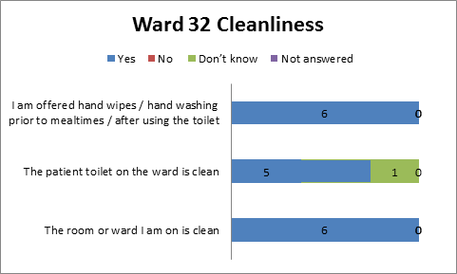
Cleanliness:
All 6 respondents stated that the ward was clean and 5 of the respondents stated the patient toilet area was clean with one stating they did not know. All respondents stated that they are offered hand wipes / hand washing prior to mealtimes / after using toilet.

Care & Treatment
6 of the respondents stated they felt the staff were approachable with 2 commenting that they were mostly approachable. 4 of the 6 respondents felt staff answered their questions well enough. 5 of the 6 respondents stated they were made to feel comfortable during the day. 5 of the 6 respondents stated they were not aware that they had a choice of chair to sit in. There were 3 additional comments regarding the bed side chair below:
‘The chair is too small. I am tall and have a bad knee. I am uncomfortable’. (New style chair)
Patient was not aware of choice of chair but stated ‘I am comfortable’ (New style chair)
No, I did not know but I am using cushions to sit on’ (New style chair)

There was a mixed response to how long patients sat in their chair and it appeared to be patient’s choice as to whether they sat in their chair or lay in their bed. When asked if they had confidence in the staff treating them 5 out of 6 stated yes with 1 respondent stating no and that some staff at night were aggressive. 5 of the 6 respondents stated there was no hospital information folder next to their bed. 4 of the 5 respondents said they could request a bath or shower whenever they felt they needed one with 1 patient stating they were washed in bed.

Nutrition and hydration
Only 2 respondents stated they were happy with the choice of food they were given but this was for reasons to do with dentures. Please see comments below:
‘No they lost her teeth, lost in box when lots of people were about’
‘Yes, but problems with dentures’
‘Don't know as lost her teeth on another ward’
3 of the 6 respondents stated they were given the food they asked for with 1 family stating they brought in soup for their relative due to the patients dentures being lost on another ward. All 6 respondents stated yes to being offered hot and cold drinks on a regular basis.

Safety
5 of the 6 respondents said they felt safe on the ward and their emergency buzzer was in easy reach. When asked if they pressed their buzzer were they seen to quickly enough 2 respondents stated yes and 4 stated they did not know.

Environment
4 of the 6 respondents were not aware the ward had a day room. 3 of the 6 respondents were comfortable with the room temperature. 2 felt it was too hot / stuffy and 1 stated it gets too cold. 3 of the 6 respondents felt they had good access to a TV. When asked if they were disturbed at night 2 respondents stated they were from a noisy patient at night.

Kindness, Dignity & Respect
5 of the 6 respondents state they were spoken to by their preferred name with 5 stating they were not aware of the nurse caring for them that day. 5 of the respondents felt their dignity was always maintained with 1 stating it was not as the bay was too crowded and noisy. 5 of the respondents stated they were treated with kindness during the day with one stating they did not know. A comment was made below:
‘Occasionally I have been accused of lying. They don't listen when you complain they say they cannot move the patient who keeps us awake all night as there are no other beds available’.
Other comments:
‘No one brings around daily papers. Some patients cannot get down to the shop’.

Ward Observations by Enter & View Representatives

 | Bay 1 | Bay 3
RAG board | Rag rating and visitor information well displayed.
Patient Information Boards | All completed including special instructions | All completed including special instructions
Dementia Friendly | An innovative clock on the wall that stated day, date and weather | Clock to wall but details of weather not up to date.
Environment | One bed observed with no visitor chair and no visible visitor chairs or notices relating to them. One TV to window wall, no subtitles in use and not reasonably accessible to all patients | All beds had the new style high back chairs for patients. One visitor complained how it was always too hot.

Ward 33
Enter & View representation on this ward included four Enter & View representatives working in pairs to complete the questionnaires and one representative carrying out observations on the ward.
Completed Questionnaire responses:
In total there were 8 completed questionnaires on ward 33. Please see below for the themed responses

Cleanliness:
All 8 respondents stated that the ward and the patient toilet area were clean. 6 of the 8 respondents stated that they are offered hand wipes / hand washing prior to mealtimes / after using toilet. 1 respondent stated they were not offered this and 1 stated they did not know as they were a visitor.

Care & Treatment
All 8 respondents stated they felt the staff were approachable with 1 stating yes but that one or two were not friendly. All 8 respondents felt staff answered their questions well enough with 1 respondent adding that it was hard during visiting times as it coincided with the staff shift changes (family member). 7 of the 8 respondents stated they were made to feel comfortable during the day. 7 of the 8 respondents stated they were not aware that they had a choice of chair to sit in. Comments about the bed side chair included:
‘No, the chair is uncomfortable’. ( new style chair)
‘No and not comfortable’. (new style chair)
‘No it’s a hard chair’ (new style chair)
‘No, have to use pillows on chair’ (new style chair)
There was a mixed response to how long patients sat in their chair and it appeared to be patient’s choice as to whether they sat in their chair or lay in their bed. When asked if they have confidence in the staff treating them 7 stated yes with 1 respondent not being able to complete the rest of the questionnaire. 6 of the 7 remaining respondents stated there was no hospital information folder next to their bed. 6 of the 7 respondents said they could request a bath or shower whenever they felt they needed one with 1 patient stating they were washed in bed.

Nutrition and hydration
*Please note now based on 7 respondents as 8th respondent is recorded as not answered with not continuing with questionnaire.
All 7 respondents stated they were happy with the choice of food and 5 stated they received the food they asked for. 1 respondent was a visitor and therefore felt could not answer this question. All 7 respondents stated they were offered hot and cold drinks on a regular basis.

Safety
All 7 respondents said they felt safe on the ward with 5 of the 7 respondents stating their emergency buzzer was in easy reach. When asked if they pressed their buzzer were they seen to quickly enough 5 respondents stated yes and 2 stated they did not know.

Environment
4 of the 7 respondents were not aware there was a day room. 1 respondent stated they had used the day room once. 4 of the 7 respondents were comfortable with the room temperature. 1 felt it was too warm and 1 stated it was too cold. 4 of the 7 respondents felt they did not have good access to a TV. When asked if they were disturbed at night 2 respondents said they were from a noisy patient at night, 1 stated the bed was too hard.

Kindness, Dignity & Respect
6 of the 7 respondents state they were spoken to by their preferred name. 3 respondents stated they were not aware of the nurse caring for them that day with 4 stating they were aware. All 7 respondents felt their dignity was always maintained and stated they were treated with kindness during the day.
Other comments:
1 patient became confused during the chat therefore the conversation was ended mid questionnaire. All responses were therefore continued as not answered.
1 relative stated that they really needed to speak with the consultant but was finding this hard, one reason being the staff change over during visiting hours.

Ward Observations by Enter & View Representatives

 | Bay 1 | Bay 2
RAG Board | Rag rating and visitor information well displayed.
Patient Information Boards | All completed including special instructions | All completed including special instructions
Stroke Friendly | Patients in bed had guard rails up, no trip hazards and bay clutter free | No trip hazards and clutter free
Environment | Large TV on wall, no subtitles in use, not accessible to all patients. All bed side patient chairs were new style | 1 old style patient bedside chair. One TV fixed to wall, no subtitles and not accessible to all patients.

Ward 34
Enter & View representation on this ward included four Enter & View representatives working in pairs to complete the questionnaires and one representative carrying out purely observations on the ward.
Completed Questionnaire responses:
In total there were 7 completed questionnaires on ward 34. Please see below for the themed responses:

Cleanliness
All 7 respondents stated that the ward was clean. 3 respondents stated the toilets were clean but this was due to other respondents being unable to answer due to being visitors. 6 of the 7 respondents stated that they are offered hand wipes / hand washing prior to mealtimes / after using toilet and 1 stated they did not know as they were a visitor.

Care & Treatment
All 7 respondents stated they felt staff were approachable. 6 respondents felt staff answered their questions well enough with 1 stating yes but within their rules. 6 respondents stated they were made to feel comfortable during the day with 1 respondent not answering this question as they were a visitor and did not feel they could answer on behalf of the patient. 6 of the respondents stated they were not aware or stated it was not applicable to them that they had a choice of chair to sit in. Comments about the bed side chair included:
‘No, but I am happy’ ( new style chair)
‘Didn’t know but the chair is ok’ (new style chair)
‘No, use pillows on chair’ (new style chair)
‘No but I use my own chair’ (wheelchair)
There was a mixed response to how long patients sat in their chair but 6 of the 7 respondents replied with comments such as:
‘most of the day’
‘up to 12 hours’
‘all day’
When asked if they had confidence in the staff treating them all 7 respondents stated yes, but comments included:
‘Physio didn’t turn up but the nurse helped’
‘Yes, but not always’
6 of the 7 respondents stated there was no hospital information folder next to their bed. 6 of the 7 respondents said they could request a bath or shower whenever they felt they needed one.

Nutrition and hydration
4 of the 7 respondents stated they were happy with the food choice. 1 respondent stated breakfast was boring and another stated there were too many salads. 6 respondents stated they received the food they asked for with 1 stating there were not hungry. All 7 respondents stated they were offered hot and cold drinks on a regular basis.

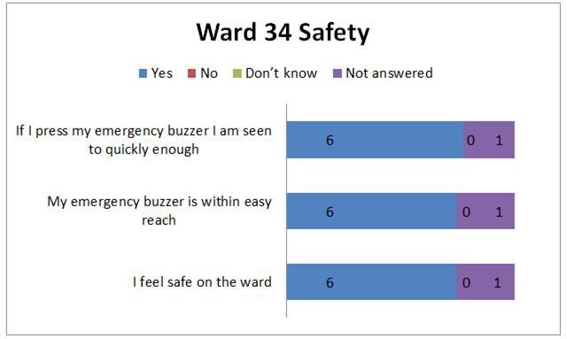

Safety
Please note only 6 respondents continued with the questions
All 6 respondents said they felt safe on the ward with 1 respondent stating there was a certain amount of uncertainty. All 6 respondents stated their emergency buzzer was in easy reach and that they were seen to quickly enough.

Environment
4 of the 6 respondents were aware that there was a day room although 3 of the 4 respondents stated they were aware but had not used it. 4 of the 6 respondents were comfortable with the room temperature with 1 stating they were comfortable because they were near the window. 2 respondents felt it was too hot. 4 of the 6 respondents felt they did not have good access to a TV. All 6 respondents stated they were not disturbed at night.

Kindness, Dignity & Respect
All 6 respondents stated they were spoken to by their preferred name. 5 of the 6 respondents stated they were aware of the nurse caring for them that day. All 6 respondents felt their dignity was always maintained and stated they were treated with kindness during the day.

Other comments:
- Patient was concerned about his future and had little knowledge or feedback from his family. Patient not sure who their consultant was.
- A patient was without their hearing aid. Family stated it was lost when first admitted to hospital in March 2016. Healthwatch reported to PALS and Director of Nursing.

Ward Observations by Enter & View Representatives

 | Bay 4 | Day Room
RAG board | Rag rating and visitor information well displayed.
Patient Information Boards | All completed including special instructions | N/A
Dementia Friendly | No trip hazards and bay clutter free. A memory lane of photos, pictures and signs visible approaching corridor to ward. But stopped at the entrance to the ward. Not visual in patient areas | No observations recorded
Environment | Clean and free of clutter. All beds had new style patient chairs. One TV for bay, no subtitles in use, not accessible to all patients | Good environment, chairs, bookcases, pictures and TV. No clear notices were observed in bays to inform patients and visitors of the day room

Conclusion
During both visits the Healthwatch Sefton Enter & View Representatives were greeted by staff and made to feel welcome. Open access was given on the wards and any special instructions regarding infection control was provided.
Healthwatch Sefton carried out the Enter & View visits on the selected wards to mainly find out how comfortable and safe patients felt with the new bedside chairs with the integrated pressure relieving cushions that had been introduced by the Trust. As can be read in this report although some patients felt they were comfortable many commented that they were not and observations included patients using pillows to help with their comfort whilst sat in the new style chair. The Trust has stated that the old style blue reclining chairs are stored on the wards and patients and relatives can request this style chair but the findings show 20 of the 32 respondents who answered this question said they were not aware of this.
The report also highlights how patients, family and visitors all felt the ward / bay areas were clean including the patient toilet area. In addition patients, family and visitors overall had confidence in the staff treating and supporting them and found the staff approachable.
Healthwatch Sefton would ask the Trust to circulate instructions / policy to ward staff on the procedures that are in place to support patients who have had their dentures lost or experiencing problems with them. This was a particular problem for patients during meal times.
The issue regarding the patients lost hearing aid was dealt with promptly by the Trust when reported to PALS and the Director of Nursing. The Head of Audiology has contacted Healthwatch Sefton to provide assurance on the processes in place on the wards which includes:
- All wards now have a designated Deaf Champion who links in with Audiology over Deaf Awareness matters including lost hearing aids.
- All wards now have a communication device to help in the interim while a lost hearing aid is getting replaced
- The issue was being raised with the Deaf Champion on ward 34.

Healthwatch Sefton would like to thank the Trust for working in partnership in ensuring patient; family and visitors voices are heard and listened to.
Healthwatch Sefton would welcome a response from the Trust to be published along with this report.

Response from Aintree University Hospital NHS Foundation Trust

A formal response to the report was received 15th September 2016, within the statutory 20 working day response period. Nicola Firth, Director of Nursing and Quality responded as follows;

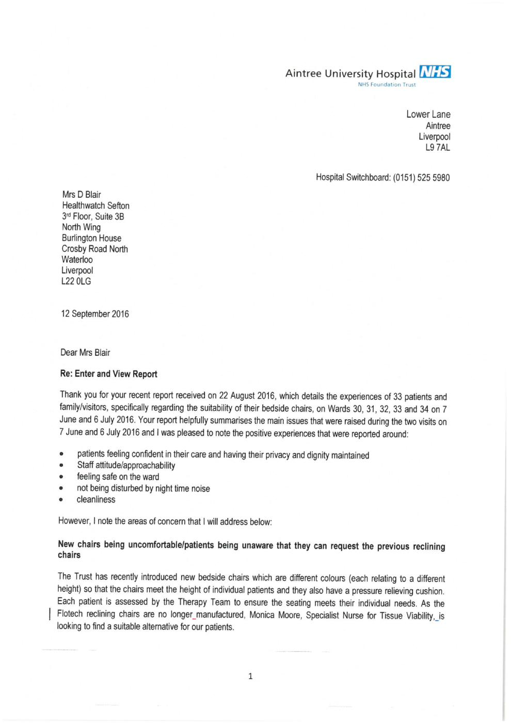
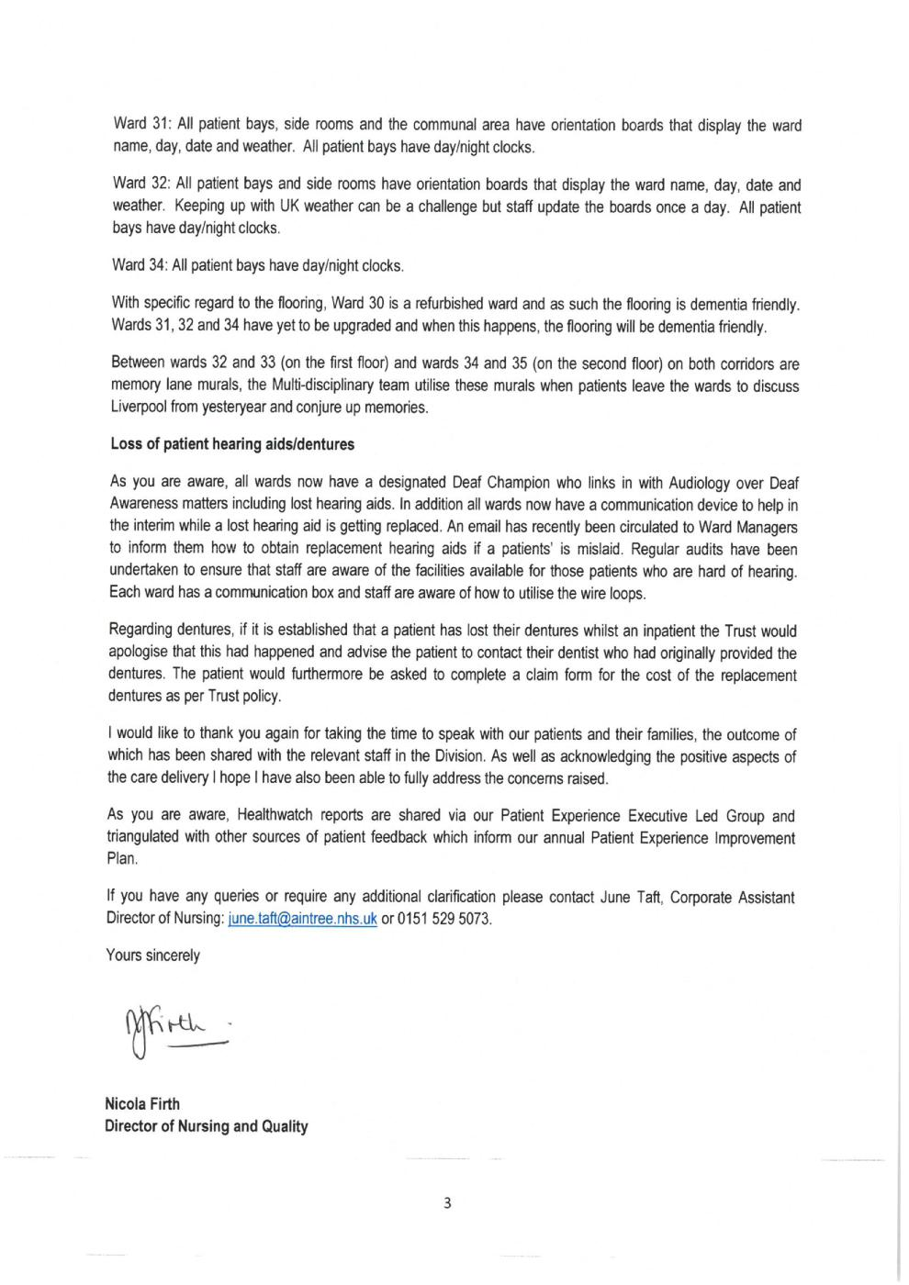
Appendix 1
Questionnaire regarding the Frailty and Rehabilitation wards

Age |  |  | Date of admission
Sex | M / F |  | Current date
 |  |  | Time of visit
 |  |  | Ward

Who did you speak with (patient / family / friend? ……………………………………………………

Please tick in the box to indicate your response.

CLEANLINESS | YES | NO | DON’T KNOW | COMMENTS
The room or ward I am on is clean

The patient toilet on the ward is clean

I am offered hand wipes / hand washing prior to mealtimes / after using the toilet

CARE & TREATMENT | YES | NO | DON’T KNOW | COMMENTS
How long have you been on this ward? (answer in comments)
Do you find the staff approachable to speak to?

When I ask a question of staff, they answer me well enough
During the day I am made to feel comfortable

I am aware that I have a choice of chair to sit in next to my bed
On average how many hours a day are you sat in the chair next to your bed? (answer in comments)

I have confidence in the staff treating or supporting me
I have a hospital information folder next to my bed

I am able to request a bath or shower whenever I feel I need one

NUTRITION & HYDRATION | YES | NO | DON’T KNOW | COMMENTS
I am happy with the choice of food I am given

I am given the food that I ask for

I am offered hot and cold drinks on a regular basis

SAFETY | YES | NO | DON’T KNOW | COMMENTS
I feel safe on the ward

My emergency buzzer is within easy reach

If I press my emergency buzzer I am seen to quickly enough
ENVIRONMENT | YES | NO | DON’T KNOW | COMMENTS
I am aware there is a day room

I am comfortable with the room temperature on the ward
I have good access to a TV at my bed

Are you disturbed at night?

KINDNESS, DIGNITY & RESPECT | YES | NO | DON’T KNOW | COMMENTS
I am spoken to by my preferred name

I am aware of the nurse caring for me today

My privacy and dignity is always maintained

I am treated with kindness in my day to day care

If you have any additional comments or questions, please feel free to include them below:

If you would like a copy of this report please provide contact details below. Your details will not be shared with the provider or any other organisation.

Name:

Address:

Volunteer observations form

Patient Information Board:

Dementia friendly:

Comments on environment:

Any other observations:
(Please check the RAG rating outside the ward on the visit)

Appendix 2
FEEDBACK FORM FOLLOWING ENTER & VIEW BY AUTHORISED REPRESENTATIVES.
Healthwatch Sefton values any constructive comments that would help to enhance our practice of the Enter & View process. Could we therefore ask the service provider to use this form to provide feedback to help us evaluate our effectiveness? Your feedback will be included in the published report.
Organisation Address |  | Premises – if different
Aintree University Hospitals NHS Foundation Trust
Longmoor Lane
Liverpool
L9 7AL

Contact Name |  | Telephone number and/or email
Beth Baines |  | Beth.baines@aintree.nhs.uk
Name of Healthwatch Enter and View Authorised Representatives |  | Wendy Andersen (7th June and 6th July)
 |  | Betty Boner (6th July)
 |  | Maurice Byrne (7th June)
 |  | Diane Foulston (7th June)
 |  | Brian Clark OBE (6th July)
 |  | Ken Lowe (7th June and 6th July)
 |  | Nigel Smith (6th July)
Date & Time of Visit |  | 7th June 2015  6th July 2016
Were you happy with the Enter and View arrangements prior to the visit? Comments -
Yes, I was fully informed of all relevant information

Please outline any positive aspects of the Enter and View visit. Comments –
It’s really helpful to have feedback from a separate organisation who can often highlight issues that we have not previously identified

Please outline any negative aspects of the Enter and View visit. Comments -
None to report

Please use this space to comment on how you think we could improve your experience of our Enter & View visit. Your views are very important to us at Healthwatch Sefton and we appreciate, in anticipation, your time to complete this form.
I feel very positive about both verbal and written feedback from Healthwatch Sefton and I will continue to implement any changes or improvements to quality, safety and patient experience based on any feedback that we receive. I am also a great advocate of sharing good practice so any issues raised through feedback are then discussed at my daily safety huddles with all my ward managers from the DME/Stroke division and where appropriate escalated to share at the daily matrons safety huddles.

Completed by: | Beth Baines
Position: | Matron DME/Stroke
Date: | 02/08/16

