Enter and View Report
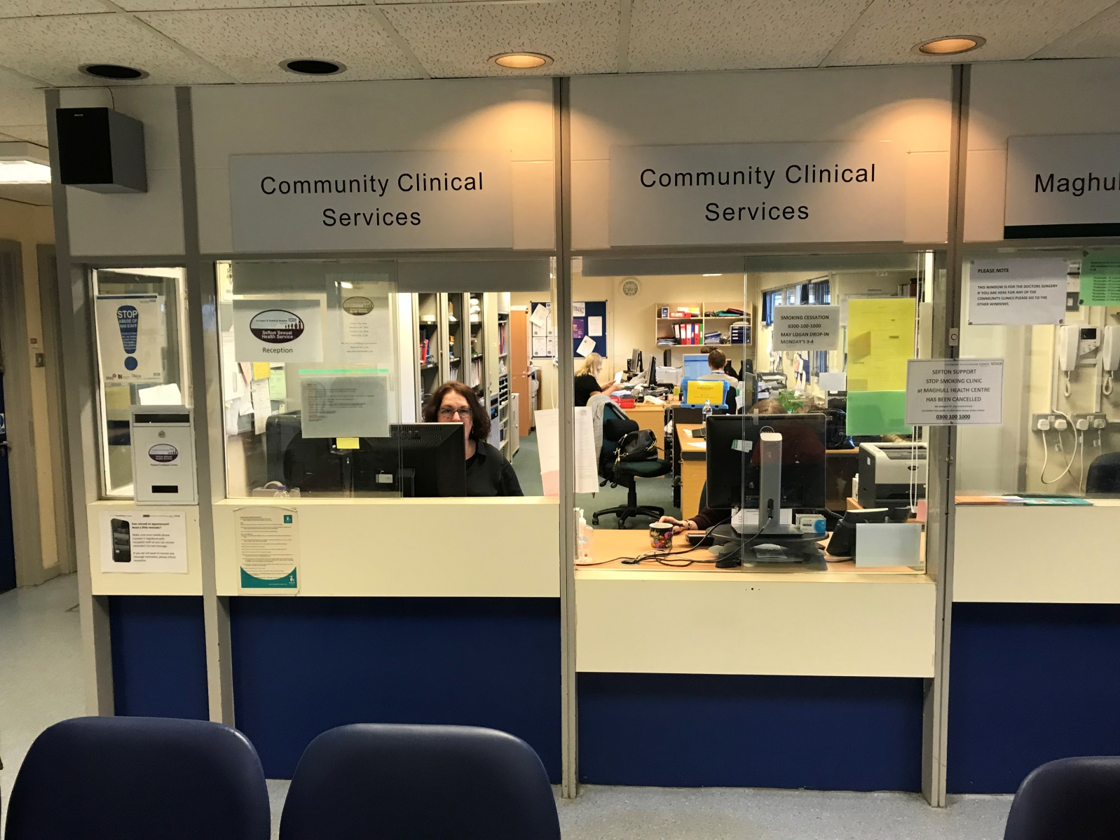
Announced Enter & View visits to:
Community Services,
Maghull Health Centre,
Westway, Maghull, L31 0DJ
Provider: Mersey Care NHS Foundation Trust

Contents
Heading | Page No.
Healthwatch Sefton Authorised Representatives | 2
What is Enter & View? | 3
Summary of main findings | 4-5
Introduction | 6-7
Mersey Care NHS Foundation Trust | 8
Acknowledgements | 8
Snapshot | 9
Key Themes | 10-21
Reviews | 22-32
Conclusion and issues to be reviewed (Action plan) | 33-35
Response from Mersey Care NHS Foundation Trust | 36-42
Feedback Questionnaire | 43-44
Contact us | 45

Details of Healthwatch Sefton Authorised Representatives and Enter & View visit dates:
Date | Authorised Enter & View Representatives
9th January 2018 | Wendy Andersen / Bridget O’Toole
11th January 2018 | Wendy Andersen / Maurice Byrne
16th January 2018 | Wendy Andersen / Brian Clark
25th January 2018 | Wendy Andersen / Maurice Byrne
29th January 2018 | Wendy Andersen / Maurice Byrne

What is Enter and View?

Enter and View is about seeing and hearing for ourselves how services are being run and allows Healthwatch Sefton to collect the views of service users at the point of service delivery. This might involve talking to staff, service users or observing service delivery.
Enter and View visits are conducted by ‘Authorised Representatives’ for Healthwatch Sefton who are trained volunteers and staff members.
Visits can be announced or unannounced.
All Enter and View visits have a clear purpose as identified by Healthwatch Sefton to ensure effective evidence gathering and reporting.
The Local Authorities (Public Functions and Entry to premises by Local Healthwatch Representatives) Regulations 2013 allows local Healthwatch ‘Authorised Representatives’ to collect the views of service users, patients and residents, collect the views of carers and relatives, collect the views of staff, observe the nature and quality of services and provide feedback.
Enter and View visits can happen if people tell us there is a problem with a service but equally, they can occur when services have a good reputation – so we can learn about and share examples of what they do well from the perspective of people who use the service first hand.

Summary of main findings

- Five announced Enter & View visits took place within community services provided at Maghull Health Centre during January 2018 resulting in 83 completed reviews / feedback forms.

- Community services at Maghull Health Centre provided by Mersey Care NHS Foundation Trust scored an average Healthwatch Sefton rating of 4 stars out of 5. (Note: Phlebotomy clinical services are sub-contracted to North West Boroughs Healthcare NHS Foundation Trust).

- Staff attitude – achieved 96% positive reviews / feedback.

- Quality of Treatment and Care – achieved 93% positive reviews / feedback.

- The phlebotomy clinic was identified as having only one nurse on a Thursday which patients felt resulted in much longer waiting times to be seen.

- It was identified through talking with patients and staff that GP surgeries had different referral systems into the phlebotomy services.

- Booking of phlebotomy appointments – It was highlighted via patients and staff that some patients prefer to book via the reception desk due to difficulties getting through on the phone lines.

- Patients continue to report difficulties in getting through on the phone lines to Maghull Health Centre and confusion with the answer service. The Trust has stated they are currently in the process of advertising for a part-time receptionist for Maghull Health Centre to support the morning clinics.

- Podiatry shared treatment room - patients who were spoken to were happy with the clinical environment.

- Podiatry booking of routine appointments – Patients spoken to stated they would prefer to be able to book their appointments as they leave the clinic. Staff spoken to also stated this would help with the phone line issues. This is an on-going issue from the previous outreach at the centre during October – November 2016. A podiatry task & finish group was set up by the previous community service provider, Liverpool Community Health NHS Trust, who identified through a supply & demand exercise a shortage of podiatrists and that 2 additional podiatrists were needed to be able to offer this service. This is an outstanding action.

- Disability Access was highlighted as an issue during the previous outreach October – November 2016. Access continues to be an issue via the double doors within the centre and the car park. Since the outreach carried out during 2016 an electronic intercom has been installed to assist patients and visitors but during the Enter & View visits it was found patients and visitors were still having difficulties not aware of the intercom.

- Notice boards in the waiting area – Identified by patients to be cluttered and not accessible to patients/ visitors with a visual impairment.

- Patient toilet – Identified by Enter & View members not clearly signposted for patients / visitors in the waiting area.

- Extra hand gel / sanitisers were requested by patients.

Introduction

This was a programme of announced Enter & View visits undertaken by authorised representatives from Healthwatch Sefton. Below photograph Maurice Byrne & Wendy Andersen.
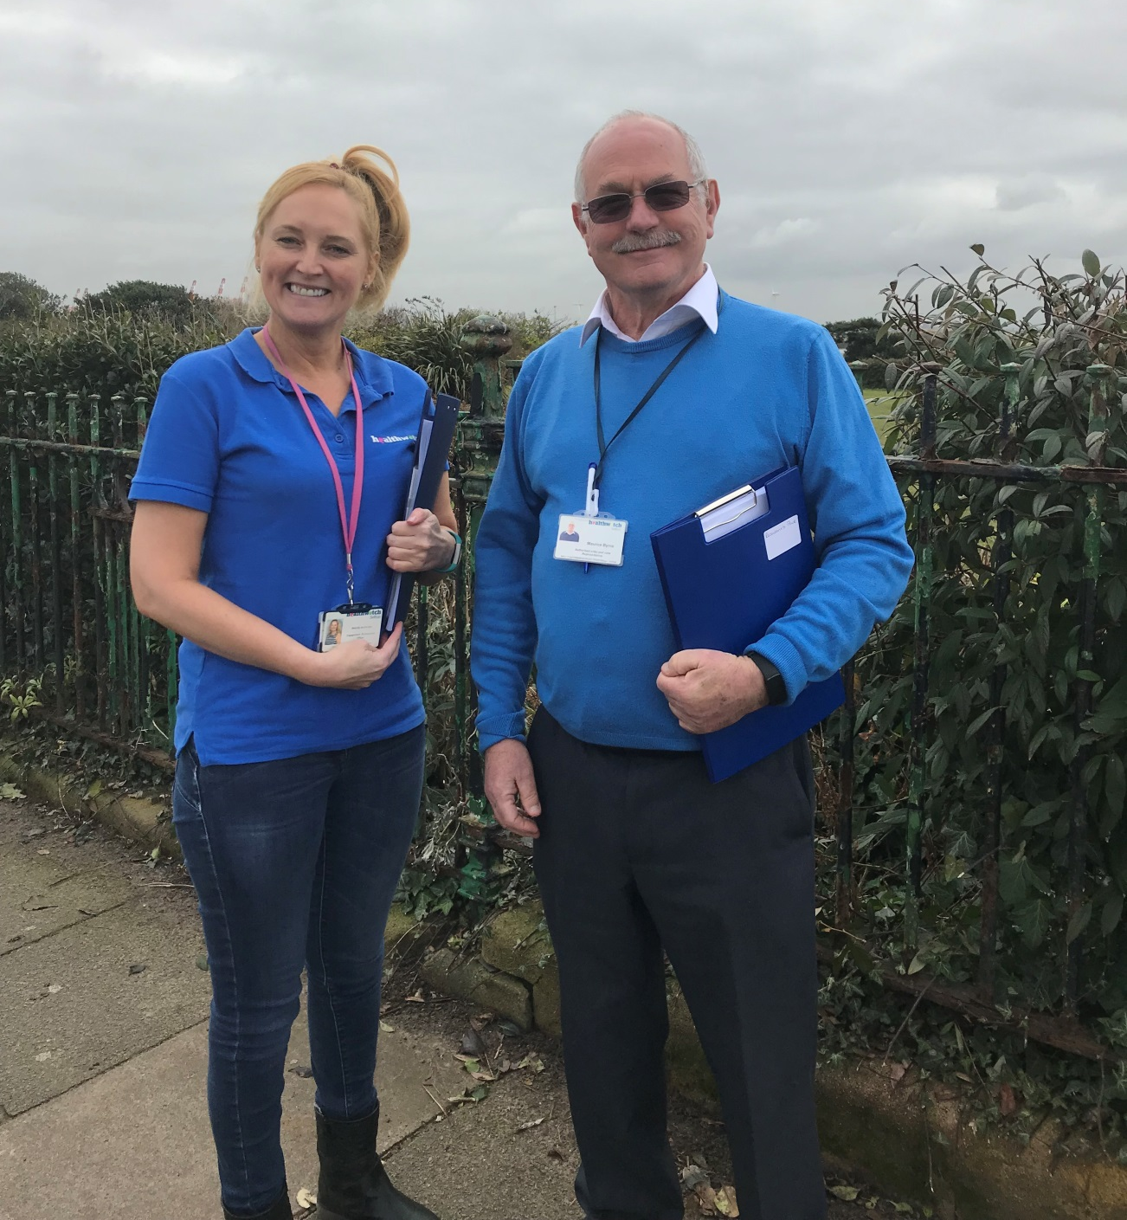

The purpose of the Enter & View visits during January 2018 was to conduct a follow up from previous outreach carried out in respect of Maghull Health Centre, community services, between October – November 2016. The provider of community services at the time was Liverpool Community Health NHS Trust. The report and subsequent action plan from 2016 can be found by visiting https://healthwatchsefton.co.uk/wp-content/uploads/2014/06/HWS-Feedback-Report-Maghull-HC-Final-with-response.pdf
The January 2018 Enter & View visits were organised in partnership with Mersey Care NHS Foundation Trust. It is noted that the clinical aspect of the Phlebotomy service is sub-contracted to North West Boroughs Healthcare NHS Foundation Trust.
The Enter & View visits during January 2018 focussed on the findings and action plan from the 2016 report including:
• Podiatry treatment room – shared treatment room space
• Booking of podiatry appointments - new and routine
• Telephone lines – patient access
• Staffing in the reception area
- Disabled access

- Community services in general
In addition to the above, whilst carrying out the Enter & View visits Healthwatch Sefton was requested by Mersey Care NHS Foundation Trust to ask for feedback specifically on phlebotomy services.

Mersey Care NHS Foundation Trust
Mersey Care provides adult specialist mental health, addiction, learning disability and community health services in North West England and beyond. Our vision is to become the leading organisation in the provision of these services. Quality, recovery and wellbeing are at the heart of everything that we do.
We provide specialist inpatient and community mental health, learning disabilities, addiction services and acquired brain injury services for the people of Liverpool, Sefton and Kirkby, Merseyside. We provide community physical health services in Sefton, secure mental health services for the North West of England, the West Midlands and Wales and specialist learning disability services across Lancashire, Greater Manchester, Cheshire and Merseyside. We are one of only three trusts in the country that provide these services.

Our clinical services are provided across 40 sites across the North West. Our teams are supported by a corporate team based at our offices in Kings Business Park, Prescot, Merseyside. Over 5,000 staff serve a population of almost 11 million people. http://www.merseycare.nhs.uk/about-us/who-we-are/ Date: 01/03/2018

Acknowledgements
Healthwatch Sefton would like to take this opportunity to thank staff on duty at the time of the visits. We would also like to thank the patients, relatives and visitors for taking the time to speak to us and for their contribution to the announced Enter & View visits.

We would also like to thank the following staff in particular for their support with the planning of the Enter & View visits to Maghull Health Centre:

- Claire Ravenscroft, Business Manager, South Sefton Community Services Division
- Nicky Ore, Sefton Locality Clinical Lead
- Sue Keech, Podiatry Team Leader

Snapshot

The following information provides a snapshot of the information provided during the five Enter & View visits - January 2018. During this period there were 83 reviews / feedback forms received and the Trust scored an average Healthwatch Sefton rating of 4 stars out of 5.

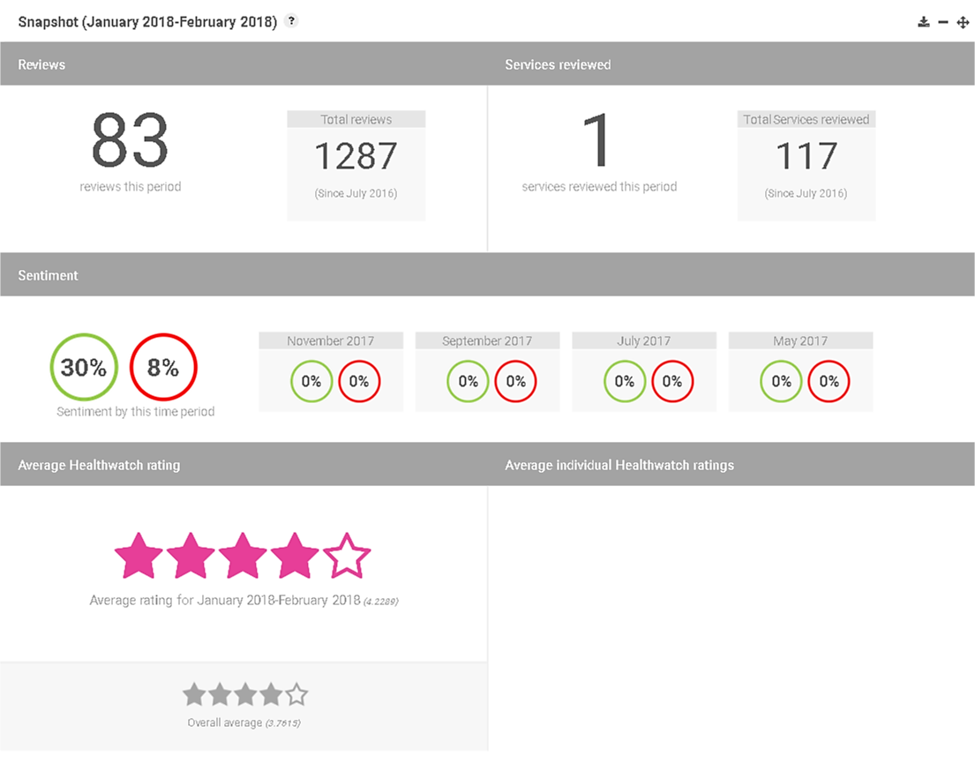

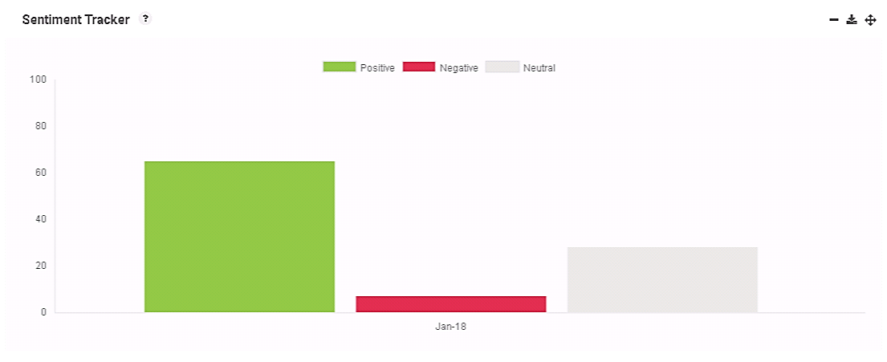
As can be seen from the below table the sentiment of the reviews / feedback are analysed as being an average of 65% positive, 7% negative with 28% neutral.

Key themes:
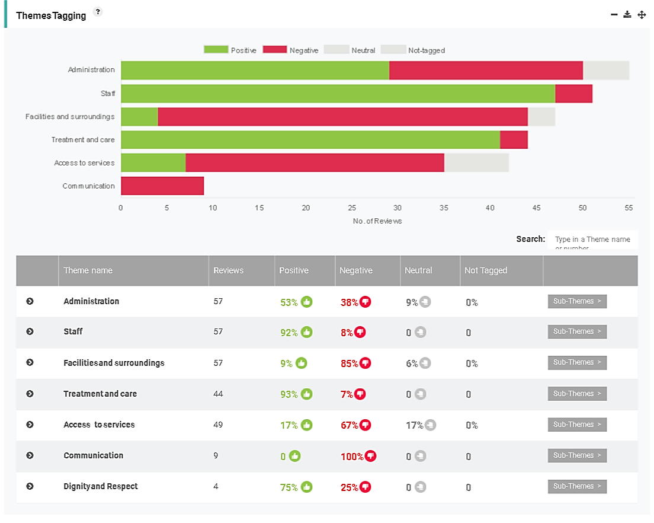
The above table shows the main areas of feedback / reviews received and their level of sentiment.
Two of the key themes commented on positively were:
- ‘Staff’ - achieved 92% positive feedback from a total of 57 reviews.
- ‘Treatment & Care’ achieved 93% positive feedback from a total of 44 reviews.
Two of the key themes commented on negatively were:
- ‘Facilities & Surroundings’ resulted in 85% negative feedback from a total of 57 reviews.
- ‘Access to Services’ resulted in 67% negative feedback from a total of 49 reviews.
The above themes are broken down further in the next part of this report.
Administration:
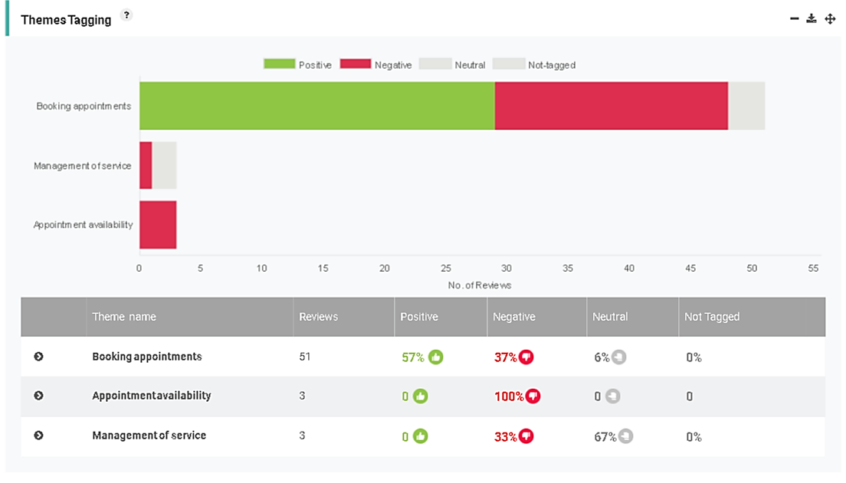
As can be seen from the above table ‘Administration’ has been broken down into sub-themes.
The main feedback received is in relation to ‘booking appointments’ which resulted in 57% positive feedback and 37% negative feedback from a total of 51 reviews / feedback received. Phlebotomy, Podiatry and Treatment room services were included in the feedback. Some of the comments received are below:
‘Bloods service - very good.
It is not possible to get an appointment by phone, had to call in to make it and did get the date I wanted.
(Communication 3 stars - phone line’)

Bloods service -
‘The main problem is parking. I live some distance, other than this I am content with the service.
It is easier to drive here and call in to make an appointment than use the phone. It was quick to get an appointment.
Waiting times depend on demand and number of blood nurses’.
(Communication 3 stars phone lines)

‘The staff are friendly. It is accessible. I managed to get a space today. Struggle to get through on the phone to book appointments for bloods’.

‘Here for bloods today. You cannot get through on the phone lines. I ended up ringing Litherland. You end up having to call in to get an appointment. The answer service kicks in with lots of other numbers. The service works ok once you get here. You expect to wait at least half an hour once here.
My husband works and has to get here for 8.30am and he says about the queues.
You cannot get a car park space; you have to park in Morrison’s’.

‘Mum has never had a problem with this service. The staff are nice and make you feel comfortable. We parked in the supermarket. You can never get through on the phone line’.
‘I can never get a space here and have to park in Morrison's. The staff are friendly and it is easy to book an appointment in person’.
‘This service is good - I don't ring for appointment, I come in. The phone can ring for hours’.
The treatment room is good and everything with the service is good. I managed to park in Morrison’s. I have no problem booking appointments (in person).

Positive feedback received was mainly in relation to being able to book appointments at the reception desk. The telephone lines for appointments were mainly commented on negatively.
For all reviews during January 2018 please see the review section.

Staff
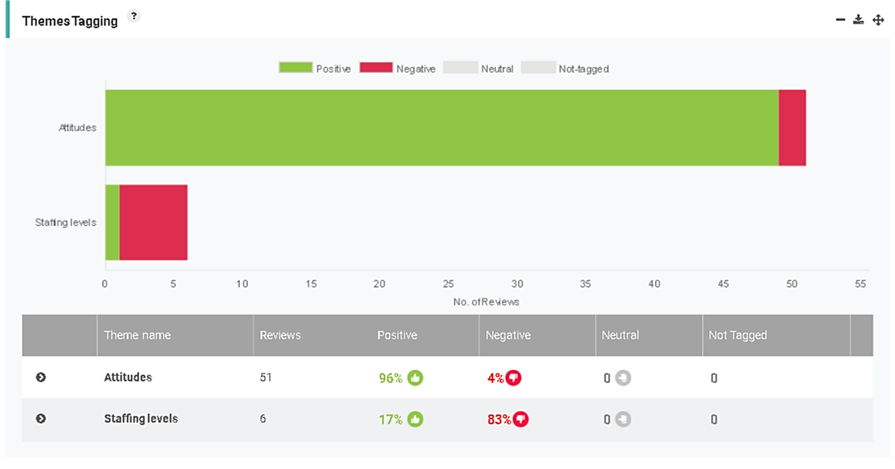
As can be seen from the above table ‘Staff’ has been broken down into sub-themes.
The main feedback received is in relation to ‘staff attitudes’ which achieved 96% positive feedback. The included both Reception and Clinical staff. Some of the comments received are below:
Podiatry – ‘First appointment. I don't think I have waited long to get this first appointment. It is local for me. The staff on reception are always fantastic here’.
‘Bloods - 5 stars
Staff attitudes 5 stars both clinical and reception staff’.

‘Podiatry - brilliant 10/10.
The podiatrist made my appointment as I left for just over 4 weeks time. Ben on reception is a smashing lad and so are the 2 girls on reception. They are so good if they could not get me in here they would look at other clinics. I can recommend them all.
The shared podiatry room is no problem for me. The podiatrist was also cleaning up when I was leaving’.

Blood service – ‘Generally ok but the waiting times are an issue.
Both the reception staff and nurses are nice’.

Staffing ‘levels’ received 6 reviews resulting in 83% negative feedback. The comments mainly concerned phlebotomy nurse staffing levels. Some of the comments are below:

‘I call in when I need to book my blood appointments and this works fine for me.
I only live across the road.
All the staff are lovely. I have been here since 8.30am and had approx 30 min wait today. There were a lot of patients here. No improvements to be made. 2 nurses on today. When there is only 1 nurse there is a long wait’.

Bloods service – ‘only 2 members of staff. I have been waiting over half an hour. When you get here for your appointment you have to take a ticket. They need an extra bloods member of staff. You usually wait approx half an hour.
I never try to ring for an appointment, I always just call in. Reception staff are mostly nice but sometimes it feels like they can ignore you when you are at the desk’.

It was noted during the Enter & View visits that there was only one phlebotomy nurse on duty during the Thursday clinic.

Staffing levels / shortages within the Maghull Health Centre reception area was also highlighted as an issue during the previous outreach October – November 2016. It is noted that the Trust is currently out to recruitment for a part-time reception member of staff to cover the morning shift at Maghull Health Centre.

For all reviews during January 2018 please see the Review section.

Facilities & Surroundings

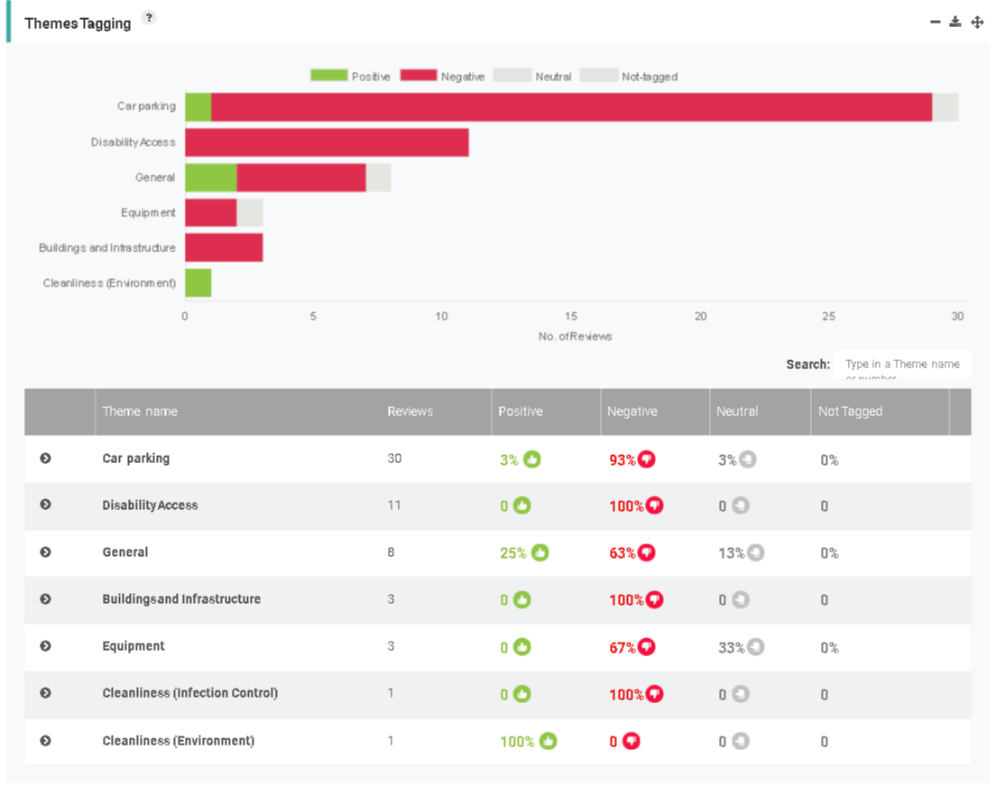
As can be seen from the above table ‘Facilities & Surroundings’ has been broken down into sub-theme.

30 reviews / feedback forms were concerning ‘car parking’ resulting in 93% negative feedback. This was mainly concerning lack of spaces and disabled spaces.

11 reviews / feedback forms were concerning ‘disability access’ which resulted in 100% negative feedback. This was also an area highlighted as a concern in the 2016 report.

8 reviews / feedback forms were recorded as ‘general’ that resulted in 25% positive feedback and 63% negative. This included areas such as notice boards being cluttered / not good for visually impaired in the waiting area and the environment being tired and needing to be updated.

Some of the comments received are below:

‘Bloods service rated 5 stars. System works well at the desk. The toilets are not easily accessible. More hand cleansers are needed. The notice boards are too cluttered and not good for people with sight issues’.

Bloods – ‘prefer quicker appointment times. Environment needs a paint. Staff attitude and quality of treatment 5 stars’.

Bloods – ‘Visited reception to make appointment. 1 week to wait is too long.
The environment is tired. Car parking is an issue.
Quality of treatment and staff attitude 5 stars’.

Bloods service – ‘Very impressed. We are new to the area. The staff are lovely on reception’ (not been seen yet).
Access – ‘Quite a few double doors and have a stick. Can be hard but I have my wife. What about people in wheelchairs or have prams. We were not told of any delay but we can see how busy it is’.

‘Podiatry is a good service; I get seen every 3 months. I ring but they are sometimes busy so I phoned Netherton and they made my appointment. The staff are very good with you when you ring up. The podiatrists are very helpful’.
Bloods service –‘ I cannot grumble when you see how many patients they have to see. The staff are very nice and helpful, both clinical and reception.
If I come in my chair it is very awkward, so I have to get out of my chair and use my stick to get in’.
(Patient informed of the buzzer system on door as was not aware).

‘Having recently become disabled I have found the difficulty in accessing Maghull Health Centre an added distress to my situation. I attempted to attend my appointment independently for the first time and experienced the following:
No available disabled parking available (three spaces only)
Parked some distance away from the Health Centre
Found this very distressing as I had an appointment as I had a specific appointment time.
I managed to get to the clinic doors, but had to wait for another person to open it for me - again. This was causing distress as I was worried about my appointment time and felt embarrassed.
By the time I accessed the building I was too distressed to see the podiatrist and just wanted to go home. I found the whole experience humiliating’.

For all reviews during January 2018 please see the Review section.

The issue of access via the double doors was also raised in the previous Healthwatch Sefton report 2016. Since then a video intercom has now been installed but on chatting with patients, relatives and visitors they were unaware of the system in place to support people with access difficulties.

Car parking and disabled access at the centre for patients / visitors remains a prominent issue.

Treatment & Care

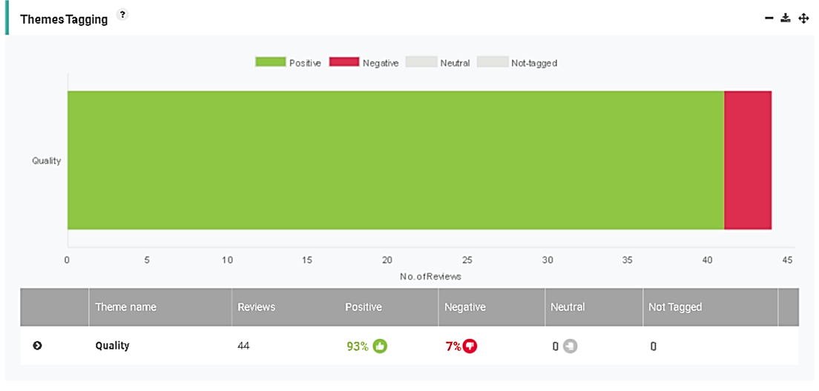

As can be seen from the above table ‘Treatment & Care’ has been broken down into the sub theme of ‘Quality’. Quality has achieved 93% positive feedback from 44 reviews / feedback forms with 7% negative feedback. Some of the comments are below:

Bloods – ‘prefer quicker appointment times. Environment needs a paint. Staff attitude and quality of treatment 5 stars’.

‘Bloods - 5 stars
Staff attitude 5 stars both clinical and reception staff’.

Treatment room – ‘Works very well. The staff are very pleasant nurses and reception. I normally call in to make my appointments. Nothing to improve’.

Bloods service – ‘A good experience. I usually get the bus or walk here. The nurses and reception are nice. I booked my appointment 4 days ago and got to pick my day’.

For all reviews during January 2018 please see the Review section.

Access to services

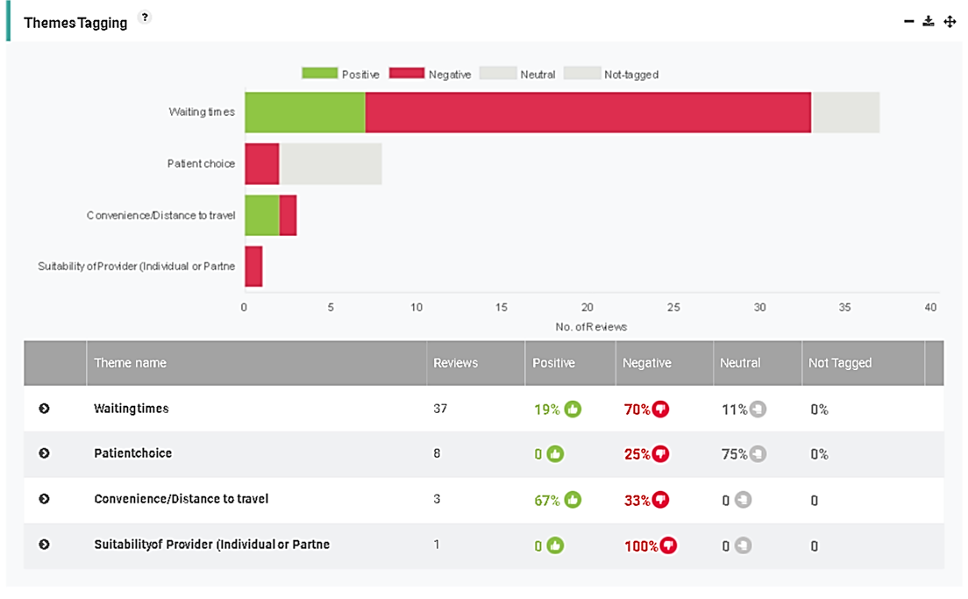

As can be seen from the above table ‘Access to Services’ has been broken down into sub-themes. The main feedback was in relation to ‘waiting times’ resulting in 70% negative feedback from 37 reviews / feedback forms. Feedback included waiting to get through on the phone lines and waiting times for the phlebotomy clinic. ‘Patient choice’ resulted in 75% neutral comments and 25% negative comments from 8 reviews / feedback forms. Patients made suggestions such as the early morning slot between 8.30am to 9.30am being exclusive for people who work and or for fasting blood tests. Please see below for some of the comments received:

Bloods – ‘My GP High Pastures gave me a letter that listed the clinics and contact details. It did take a while to get through as kept getting the answer service to ring other clinics but I wanted my appointment at this clinic. I got through in the end and the staff were fine when I got through.
It was a fasting blood test but no where on the letter did it say not to eat. I had to ask when I phoned otherwise I would not have known. So far been waiting approx 20 mins and they are on number 59. I am number 71. I have had to park in Morrison's’.

Bloods – ‘It is quite good overall.
No specific appointment times are given and you can wait up to an hour.
Staff attitude good both nurses and reception’.

‘I call in when I need to book my blood appointments and this works fine for me.
I only live across the road.
All the staff are lovely. I have been here since 8.30am and had approx 30 min wait today. There were a lot of patients here. No improvements to be made. 2 nurses on today. When there is only 1 nurse there is a long wait’.

‘Here for bloods today. You cannot get through on the phone lines. I ended up ringing Litherland. You end up having to call in to get an appointment. The answer service kicks in with lots of other numbers. The service works ok once you get here. You expect to wait at least half an hour once here.
My husband works and has to get here for 8.30am and he says about the queues.
You cannot get a car park space; you have to park in Morrison’s’.

‘Bloods service works fine. I would definitely prefer an appointment system as I have had to take the morning off work’.

Bloods – ‘I would also prefer an appointment system (overheard another patient). It is the luck of the day. I am with the Maghull Health Centre GP and they told me to go to the window to make bloods appointment. Reception here are fine. So far today I have been waiting half an hour.
Car park is too small’.

Bloods – ‘People who work have to be here early but everyone comes in early. We need to get to work. Suggestion - for working people to have a choice of an actual time or use the early time for working people’.

For all reviews during January 2018 please see the Review section.

On observing the reception area during morning clinics it was observed to be difficult for the 2 reception staff on duty at any one time to be able to answer the telephone lines and man the front reception area for patients arriving to book-in and book appointments. Patients also commented that the answer service provided lots of different numbers and not wanting to book into another clinic. This highlighted the

patient’s lack of knowledge and understanding on how the appointment system worked. Communication with patients was identified as an issue.

In addition a number of patients who were in employment requested that they be able to make an appointment or be seen during an earlier timeframe e.g. 8.30 – 9.30am. Patients who attended for fasting appointments also requested that they have the early slot in the morning.

Reviews

A total of 83 reviews / feedback forms were received during the Enter & View visits in January 2018. The following Healthwatch Sefton Star rating was used:
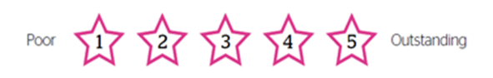
Rating | Title | Review
5 | Bloods is excellent. | Bloods is excellent. I am ok but think the waiting times could be improved. You can wait up to 2 hours. I have 20 patients ahead of me now. Sometimes they only have one nurse which is not good. The reception staff are very helpful, they have helped me with other issues. You can have nice banter with them.
4 | Would prefer appointment system | Bloods service works fine. I would definitely prefer an appointment system as I have had to take the morning off work.
5 | Bloods - would prefer appointment system | Bloods service work well but I would rather have an appointment system.  I call in to make my appointments and both reception and clinic staff are good.
5 | Bloods is very good | Bloods is very good. Personally I would rather have an appointment as think this could improve the system.  Both staff on reception and in clinic are good. I am with the Maghull Practice GP and they send you to the window to make your appointment.  Parking is not fantastic; you have to park Morrison's.  I have to book the morning off work as you don't know how long you will be.
5 | Bloods - service is brilliant | Bloods - service is brilliant. I phoned for my appointment and got through ok. I have been before and nothing to improve.  Needs more doing with environment - car parking. They rely on Morrison's.  Appointment waiting times can vary.
3 | Bloods - would prefer appointment system | Bloods - I would also prefer an appointment system (overheard another patient). It is the luck of the day. I am with the Maghull Health Centre GP and they told me to go to the window to make bloods appointment. Reception here are fine. So far today I have been waiting half an hour.  Car park is too small.
5 | Bloods system works very well | Bloods system works very well. I come once a year and nothing to improve. My GP surgery High Pastures told me to make an appointment so I called in. The staff on reception at Maghull are all fine. The waiting times don't bother me as I have all day.
5 | Bloods system works well | The bloods system works well. Sometimes there can be only a few waiting but 20 in front of me today. The nurses are working quickly even though don't know how many there will be. The staff on reception and in the clinic are helpful. When I phoned for my appointment I got through on the second try. The waiting area is good. Waiting times vary depending on the volume of patients.
5 | Bloods service rated 5 stars | Bloods service rated 5 stars. System works well at the desk. The toilets are not easily accessible. More hand cleansers are needed. The notice boards are too cluttered and not good for people with sight issues.
5 | Bloods - fasting | Bloods - There are no special plans in place for fasting blood appointments. The clinic could do with painting.
5 | Bloods - prefer quicker appointment times | Bloods - prefer quicker appointment times. Environment needs a paint. Staff attitude and quality of treatment 5 stars.
5 | No issues booking appointments | Bloods - no issues booking appointments on phone or reception.
5 | 1 week to wait for bloods is too long | Bloods - Visited reception to make appointment. 1 week to wait is too long.  The environment is tired. Car parking is an issue.  Quality of treatment and staff attitude 5 stars.
4 | Bloods - working people | Bloods - People who work have to be here early but everyone comes in early. We need to get to work. Suggestion - for working people to have a choice of an actual time or use the early time for working people.  (unable to complete all of the form)
4 | Podiatry - she explained everything | It is my first podiatry appointment today. Think I have waited about 8 weeks. It is local for me to get to. The shared treatment room is fine for me. The chair was comfy and she explained everything. I have been told to pop along to the clinic about a week before my next appointment is due to book.  Bloods - is all fine, spot on. The ticket system works fine. The waiting times are not too bad. The staff are all fine, they are good.  About a month ago I was received a phone call to come the following morning for podiatry appointment. I got here and checked in then about 10 minutes later I was told my appointment had been cancelled. The excuse was staff shortages.
5 | Staff on reception always fantastic | Podiatry - First appointment. I don't think I have waited long to get this first appointment. It is local for me. The staff on reception are always fantastic here.  (Patient called away not completed all of form)
5 | The ticket system works well | Bloods - Nothing can be improved. The ticket system works well. The car park is bad, there are not enough spaces. The girls on reception are lovely and happy.
5 | The staff are lovely | I live by the Alt and the bus is every hour so I have to try and arrange appointments to fit in. There is no where more local for me. Netherton would take a lot longer to get to. I usually ring and book appointments and the phone lines have been ok for me but other people tell me they have difficulties. The staff on reception and in the clinic are lovely.  (Patient called away unable to finish form)
5 | The staff are brilliant | Bloods - I come every 2 months. I am with Dr Sapre and I get a form from the doctors. I call to the desk to make my appointments. The staff are brilliant on reception and in the clinic. I have been coming for 40 years. It is always nice and I have never had problems. The waiting times are mixed but I cannot fault the service.  Environment 3 stars due to car park.
4 | Bloods is a good system | Treatment rooms - whenever I come here there are no issues.  Bloods - this is the same, no issues. Normally dealt with quickly. The appointment system for both bloods and treatment room works well. The bloods is a good system you come in and take a ticket. All the reception and clinical staff are really friendly and approachable. I normally phone for my bloods appointment and have no problems.  I don't bother bringing my car here, just park in Morrison's.  Environment scored 3 stars re: car park
5 | Bloods - recommendation for fasting | Bloods - Recommendation - When you come in for a fasting blood test there are lots of people waiting for normal blood tests. The first hour should just be for fasting blood tests. I got here for 8.30 am for a fasting test and there were already 20 people ahead of me. It does not matter to me as I don't work but I have spoke to some patients who have had to leave as they could not wait with needing to get to work. There are normally 2 nurses on and they do work as quickly as possible.  Environment - parking is an issue.
5 | Bloods - 5 stars | Bloods - 5 stars  I use the telephone lines to book.  They could do with having magazines and toys for children.
5 | Bloods - 5 stars | Bloods - 5 stars  The decor needs painting / refreshing.  I have no issues with the telephone lines.
4 | Variable skills | Treatment room (dressing) - I visit for appointments.  Quality of treatment - variable skills  Appointment waiting times - Waiting time at the centre before your appointment is often too long, more than 30 minutes.  Car parking is a big issue.
5 | Bloods and Podiatry - 5 stars | Bloods and Podiatry services 5 stars.  I visit reception for my appointments.  They could do with putting the television on for patients.
5 | Bloods - 5 stars | Bloods - 5 stars  Staff attitudes 5 stars both clinical and reception staff.
5 | Bloods service - no issues | Bloods service no issues. I make my appointment at the desk. 1 week to wait is ok.
4 | Difficulty getting through on phone | Bloods - My GP High Pastures gave me a letter that listed the clinics and contact details. It did take a while to get through as kept getting the answer service to ring other clinics but I wanted my appointment at this clinic. I got through in the end and the staff were fine when I got through.  It was a fasting blood test but no where on the letter did it say not to eat. I had to ask when I phoned otherwise I would not have known. So far been waiting approx 20 mins and they are on number 59. I am number 71. I have had to park in Morrison's.
5 | Bloods service is very good. | I was able to have my ECG done here which is much better than travelling to Aintree. It is much better to have local services.  The Bloods service is very good I was in and out when I came. Waiting times can be long. The reception staff are excellent and very helpful. I am still driving but you cannot park here, I have to park at Morrison's.
5 | Bloods - very impressed | Bloods service - Very impressed. We are new to the area. The staff are lovely on reception (not been seen yet).  Access - Quite a few double doors and have a stick. Can be hard but I have my wife. What about people in wheelchairs or have prams. We were not told of any delay but we can see how busy it is.
5 | Podiatry - 10/10 | Podiatry - brilliant 10/10.  The podiatrist made my appointment as I left for just over 4 weeks time. Ben on reception is a smashing lad and so are the 2 girls on reception. They are so good if they could not get me in here they would look at other clinics. I can recommend them all.  The shared podiatry room is no problem for me. The podiatrist was also cleaning up when I was leaving.
4 | Treatment room - works very well | Treatment room - Works very well. The staff are very pleasant nurses and reception. I normally call in to make my appointments. Nothing to improve.
4 | Easy to make appointment | Bloods service - I made my appointment at the reception desk. Dr Sapre referred me. I found it easy to make the appointment. The staff on reception are very nice and the ticket system works well for me. The nurses are nice too. I never park here; you have to park at Morrison's.  So far today my wait has been 30 mins.
5 | Staff are very helpful | Bloods service - High Pastures GP surgery gave me a letter with the details of all the clinics. I phoned here and they were busy so I phoned a different clinic as they were clear to get through to make my appointment. The staff are very helpful. I have waited approx 20 mins so far today.
5 | Bloods -The service is very good | Bloods service - The service is very good. They need to answer the phone when you are trying to book. I went through to Netherton. My GP is High Pastures and they provide you with all the telephone numbers for the clinics on a letter. The staff at Maghull HC are lovely and very good including the reception staff.  Have to park at Morrison's.
5 | A good experience | Bloods service - A good experience. I usually get the bus or walk here. The nurses and reception are nice. I booked my appointment 4 days ago and got to pick my day.
4 | Can wait up to an hour | Bloods - It is quite good overall.  No specific appointment times are given and you can wait up to an hour.  Staff attitude good both nurses and reception
3 | Waiting times are an issue | Blood service - Generally ok but the waiting times are an issue.  Both the reception staff and nurses are nice.
5 | Very good standard in all respects | Bloods service - Very good standard in all respects. Came into the desk to book the appointment on the Friday and got appointment for Tuesday - very good.
5 | All works well | Ear Syringe clinic - All works ok. It is a regular appointment for him. The staff are nice here. We have to park in Morrison's - never spaces. The temperature in the waiting area is just right as so cold outside.
5 | Podiatry works well for me | Podiatry works well for me. I don't mind the shared treatment room, although I suppose some might.  I call into reception to book my appointments and they do their best. Reception staff are marvellous. The podiatrists are all helpful.  Don't think I could get through the doors without my wife. (Patient informed of buzzer on door as was not aware of it). I am now happy to know about the buzzer as I might need it.
4 | Access difficulties | Bloods service - They will offer appointments at other clinics if they are full, but if you don't mind waiting it is ok.  I phoned and did not get through a few times. Waiting times depend what time you come and the staff on reception do tell you the busy times. I always try and come in the afternoon and this has worked the last two times for me. I have to bring mum of a morning and have also used the Netherton clinic when her appointment is urgent.  Mum sometimes needs urgent appointments and she is lucky as she has 2 daughters but some patients don't have anyone to help.  Environment - Someone always helps us (other patients) with double doors as they don't open automatically. There is enough room for her walker in the waiting area but there are no parking spaces available. I have to get mum and her walker out then go park Morrison's as mum could not make it across there.  The staff here always have time for you and explain things.
4 | Podiatry is a good service | Podiatry is a good service, I get seen every 3 months. I ring but they are sometimes busy so I phoned Netherton and they made my appointment. The staff are very good with you when you ring up. The podiatrists are very helpful.  Bloods service - I cannot grumble when you see how many patients they have to see. The staff are very nice and helpful, both clinical and reception.  If I come in my chair it is very awkward, so I have to get out of my chair and use my stick to get in.  (Patient informed of the buzzer system on door as was not aware)
5 | Very good | Bloods service - very good.  It is not possible to get an appointment by phone, had to call in to make it and did get the date I wanted.  (communication 3 stars - phone line)
4 | Generally ok service so far | Bloods service - Generally ok service so far. I need to see the nurse for my bloods, first time in a long time. The staff are very helpful here.
4 | Don't book by phone as difficult | Bloods service - I don't book by phone as difficult so call in instead. Parking is a problem here. I would walk but my wife is in a wheelchair so we have to use the car.  Communication 3 stars - because of phone line
5 | Main problem is parking | Bloods service -  The main problem is parking. I live some distance, other than this I am content with the service.  It is easier to drive here and call in to make an appointment than use the phone. It was quick to get an appointment.  Waiting times depend on demand and number of blood nurses.  Scored 3 for communication re: phone lines.
5 | Treatment generally ok | Bloods service - Generally ok. I call in to make my appointment, 2 - 3 day wait.  The building needs to be replaced although quite good bearing in mind the age of it.  I have not used the telephone line.
1 | November 2017 | Having recently become disabled I have found the difficulty in accessing Maghull Health Centre an added distress to my situation. I attempted to attend my appointment independently for the first time and experienced the following:  No available disabled parking available (three spaces only)  Parked some distance away from the Health Centre  Found this very distressing as I had an appointment as I had a specific appointment time.  I managed to get to the clinic doors, but had to wait for another person to open it for me - again. This was causing distress as I was worried about my appointment time and felt embarrassed.  By the time I accessed the building I was too distressed to see the podiatrist and just wanted to go home. I found the whole experience humiliating.
4 | Bloods - Good system | Centralised system used with quick response. I had a 3 day wait by choice. There are no set appointments by time but session only. A booked time would be better.  The TV could be used to amuse patients.
5 | All the staff are friendly | Bloods - Good experience of booking.  All the staff are friendly  Telephone booking - good  Parking - access is an issue  The environment is a bit run down
5 | Reception are always very nice | I had an appointment with my doctor at Parkhaven practice. They sent me to reception to book a blood appointment.  The process was fine. Reception staff have always been nice whether you ring or come in. Treatment was all fine today at bloods clinic.  When 2 nurses on the bloods you whizz through.
5 | Staff are brilliant on the desk | Bloods service - The process is easy, a nurse showed me to go to the desk. The staff are brilliant on the desk, they explained the system to me. I have not waited long today.  The car park is very busy and it is hard to get a space. You have to park at Morrison's
3 | Mix up with appointments | I phoned the number on my letter and they told me my appointment was Thursday between 8.30 - 12 noon (gentleman had written this down on letter). I asked if it was a fasting blood test but they could not tell me. When I arrived at Reception today she told me my appointment was booked for Friday. I definitely was told Thursday. (Appointment booking was not through reception at Maghull via a central booking line). Reception lady has let me be seen today. The staff are very nice on reception.  It looks like only 1 nurse is on today.  The anti-coag clinic is spot on for my wife.
5 | Bloods - all staff are great. | Bloods service - I walked up to reception and had an appointment for within 4 days. All the staff are great, both clinical and admin. I have not tried to use the phone.
5 | Bloods - no problem booking appointment | Bloods - my appointment was made my phone on the Monday. It was answered quickly and my appointment was made for 3 days later. This is not a problem. I chose to use Maghull HC using the list of centres able to take blood samples. This was provided with the blood test form by my GP surgery High Pastures, Maghull.  Access is very limited for the elderly and disabled. Parking is limited and most patients use Morrison's.  There is no disabled access from there and disabled parking is limited outside the centre.  The notice boards needs organising although they have improved in recent months.
5 | Bloods - much improved service | Bloods - I telephoned for my appointment - it was very quick and they answered quickly. I had a short waiting time - much improved in the last year.  In the past I have waited 1+ hour. I was also amazed at how quickly the phone was answered.
4 | I come every week - works well | Treatment rooms - I come every week and it works well. The waiting times are usually spot on. The nurse makes my appointment for me and this works well. The treatment and staff are all ok. The staff all know me on reception and they are nice.  I also attend the anti-coag clinic and they book me in. This works well too. The waiting times can be hit and miss.  The large TV screen in the waiting area has never worked; I don't know what it is for. The small TV screen - I'm not sure what this is for either. It would be difficult I would imagine to do appointment waiting times on the screen.  Car Parking - I give 1 star as I have given up trying to get a space.
1 | Bloods waiting times | Bloods today - Only 1 nurse and we have been waiting over an hour. You have to ring but that is ok if you can get through. Lately I have been ringing either Netherton or Thornton. They need to send a leaflet out to patients to explain how the system works, this would help.  They should always have 2 blood nurses on, never just 1.  The reception staff are all lovely. Even when you phone they are very helpful and nice.  Car parking is horrendous. I brought mum and there were no spaces. Mum cannot walk she is 92 years old. I had to take a chance on leaving car outside to get mum in. Access - the doors would be better if they could be automatic, it is hard to get a wheelchair in.  The hand sanitizes are sometimes empty, they need to be checked.  Podiatry - I bring my mum in and you have to keep ringing and ringing. When you get through they will say the list is not open. By time you do get through and list is open the appointments are gone. It would be better to get an appointment when you leave but this may cause them more DNA's. There is one podiatrist who can be a bit short / abrupt and it unsettles her.  1 star overall for bloods  3 star overall for podiatry  1 star given to bloods waiting times.  3 star given to podiatry communication
5 | Staff are lovely | Bloods today - The service works fine. I have waited approx half an hour but there are 2 nurses on, it is just the volume of patients. All the staff are lovely. The reception staff are all fine and when you book in they are very pleasant.  I usually have to park in Morrison’s. This is not too bad if you want to go the shops.
3 | Treatment ok and staff nice | Treatment room today - My appointment was 10.00 am it is now 10.20 pm. Not told the clinic was running late. I found a parking space today but it is limited and normally have to park elsewhere. Treatment is all ok and the staff are nice. The nurse makes my next appointment for me before I leave.  Podiatry - I come every 3 months. I have to make my appointment at reception. Sometimes I call in and sometimes I ring. Sometimes I can get through. They will usually say the appointments are not open yet and I have to keep trying. I would rather have the nurse make my appointment before I leave.
1 | Problems with car park | I had to park in Morrison's. I have a disabled badge but can never get in here to park. I have a wheeler but would not be able to use. I have to go on the outside path or onto the road.
1 | Access is an issue | Access to the building is cruel. I don't know how they get away with it. Elderly people struggle to get through the doors. People don't press the buzzer they struggle to get through the doors. I went to my MP over it.
3 | Can be a bit of a wait | Bloods - Can be a bit of a wait. Some people get here at 8.00am and wait. Both of us have waited a while in the past. The treatment is pretty good. We normally call to the desk to book, not used the phone lines.  There is nothing to improve other than waiting times. Maybe open another clinic.
4 | Staff are all ok | Dressing clinic - All alright. They told me to wash bandages. You should not wash dirty dressings. Treatment all been ok. The staff are all ok. I walk in to make appointments I don't try to ring.
5 | Hard to get appointments | For a fasting blood test you have to get here for about 8.00 am and wait as it is so busy but the clinic does not open until 8.30am.  The desk (reception) will ask who is first to arrive. It is hard to get appointments for bloods and sometimes you are told to go to other clinics. The treatment is very good and the nurses are lovely. The afternoon is never as bad as the morning.  I call into the desk to make appointments. I phoned once and could not get through; they gave out half a dozen numbers to ring. My husband cannot drive and they are sending you places like Litherland.  The car parking here is horrendous for disabled people. People park on double yellow all down the road, this is dangerous. People have to park in Morrison's. There will be an accident in that road.
5 | Trying to book appointments is hard | I have been trying to book my chiropody appointment since before Christmas. I have called in about 5 times and every time the book is full. I am fed up trying to call on the phone to get through.  Ben (reception) is fantastic. He tries his best. He is so helpful, me and my wife love him. I wish he was my son.  I have been in here and the queues at the desk are terrible. I have bad legs but if I sit down I lose my space. I have booked an appointment today for the chiropodist.  I also go the treatment rooms, this is all fine, no problems.  There is one chiropodist and I think she comes from Bootle. She is a young lady who is fabulous.  I usually get seen every 3 months but I am having to wait 4 months for this appointment. It would be great if we could have our appointment as we leave. I have really tried to get an appointment.  The treatment from the chiropody is all great.
3 | Re booking of blood appointment | Re: Booking an appointment for blood test.  I thought I had made an appointment but when I got here I had to get a ticket (I was not aware of this system) then I had to wait an hour to be seen.  Yesterday I could not get through on the phone. The letter said to ring 0151 475 4007 / 6. It states to ring this number to book appointments at Maghull, Prince St and Sefton Road. We then tried to ring Maghull direct and could not get through there either but got the answer service. The message states to make an appointment for Sefton Road and does not say Maghull. Ben or Bob answered and said yes I could make an appointment for Maghull. The answer machine message needs looking at.  Once I had my bloods appointment the treatment was all fine.
5 | It is good here | The staff are friendly. It is accessible. I managed to get a space today. Struggle to get through on the phone to book appointments for bloods.
4 | Podiatry service | This service is good - I don't ring for appointment, I come in. The phone can ring for hours.  The treatment room is good and everything with the service is good. I managed to park in Morrison’s. I have no problem booking appointments (in person)
5 | Call in to make bloods appointments | The bloods clinic works perfect. I call in to make my bloods appointments. Waiting times can vary but no more than half an hour. It is better when 2 staff are taking bloods, the movement is a lot quicker. It is always very busy but I always get a seat.
5 | Cannot get through on phones | Here for bloods today. You cannot get through on the phone lines. I ended up ringing Litherland. You end up having to call in to get an appointment. The answer service kicks in with lots of other numbers. The service works ok once you get here. You expect to wait at least half an hour once here.  My husband works and has to get here for 8.30am and he says about the queues.  You cannot get a car park space; you have to park in Morrison’s.
5 | Staff are great | No complaints about the staff. You get some real miserable people coming in and complaining, they give us older folk a bad name, but the staff are always cheerful. You can never get a parking space.
3 | Getting in here | I can get around in here but I have had to walk a long way from Morrison’s to here as no car spaces, and I am an older person. Phone lines are busy, it is hard to get an appointment for podiatry.
5 | All the staff are lovely | I call in when I need to book my blood appointments and this works fine for me.  I only live across the road.  All the staff are lovely. I have been here since 8.30am and had approx 30 min wait today. There were a lot of patients here. No improvements to be made. 2 nurses on today. When there is only 1 nurse there is a long wait.
3 | Time it properly with podiatry appointments | I need my feet doing every 3 months. I have to book 4 weeks in advance but usually my appointments are pushed forward by a week as they run out. Staff are good once you're in.
3 | Staff make you feel comfortable | Mum has never had a problem with this service. The staff are nice and make you feel comfortable. We parked in the supermarket. You can never get through on the phone line.
3 | Trouble getting in | The only thing that lets it down is when you can't get in. Over 50 attempts to get through in the past.  Yesterday I kept redialling -I rang 113 times to get in today.  I can't just walk-in to book, I work.  I always have to park in Morrison’s.
3 | I was taken off the podiatry list | When you phone Maghull HC the answer service gives you all sorts of numbers - why is this? I now call into book.  The shared podiatry treatment room is fine for me. I have had diabetes for 25 years. When I said I didn't need help with cutting my toe nails I was taken off the list even though I said I still need to be seen. Staff member ***** took me off the list and said I had no high risks. It took me 16 weeks to get back on the list and in the mean time I developed a foot problem and needed to have a procedure by the time I was seen. I am fit enough to cut my own toe nails but I did still need a 3 month check with my diabetes.  I came in last Friday to book for the end of January and they said the appointments were not open. I have come in today and they are now open so I have booked for towards the end of January.  I did contact PALS at the time but I did not get anywhere with it.
4 | Always call in for appointment | Bloods service - only 2 members of staff. I have been waiting over half an hour. When you get here for your appointment you have to take a ticket. They need an extra bloods member of staff. You usually wait approx half an hour.  I never try to ring for an appointment, I always just call in. Reception staff are mostly nice but sometimes it feels like they can ignore you when you are at the desk.  (Feedback form not complete as patient called in)
5 | Sent here from Everton | I was sent here from Everton Road health centre for bloods. Staff were great in reception.
1 | Can't get through to reception | Can't get through on phone lines, my dad had to get this appointment for me. Also you can't park; I am on double yellow lines.
1 | Parking | I can never get a space here and have to park in Morrison's. The staff are friendly and it is easy to book an appointment in person.

Conclusion and issues to be reviewed

Community services at Maghull Health Centre provided by Mersey Care NHS Foundation Trust scored an average Healthwatch Sefton rating of 4 stars out of 5.

The majority of positive reviews / feedback related to:

- Staff attitude – achieved 96% positive reviews / feedback
- Quality of Treatment and Care – achieved 93% positive reviews / feedback

The Trust held a meeting following the Enter & View visits on 13th February 2018. Healthwatch Sefton was invited to attend along with the Maghull Health Centre Reception Supervisors. The meeting was to discuss and review reception staffing levels, the reception staff job role including staff protected administration time and the booking of phlebotomy appointments. Improvements to the telephone answer service was also discussed along with being able to roll out any relevant changes agreed by the Trust to community service clinics across South Sefton.

Healthwatch Sefton would like to thank the Trust for working in partnership in ensuring patient; family and visitors voices are heard and listened to.

During the visit to community services at Maghull Health Centre, Healthwatch Sefton representatives were greeted by staff and made to feel welcome. Open access was given to the waiting area.

Healthwatch Sefton carried out the Enter & View visits to find out what patients, visitors and staff liked about services provided at the Trust and what suggestions they had for improvements.

There were a number of areas we would like to raise following the visit (see below) and we welcome a response to the report and the issues within the statutory 20 working day period of the report being received by the Trust. We would like the Trust to utilise the action plan shared to show how it will review the following:

- Mersey Care NHS Foundation Trust to share and discuss the report and findings with North West Boroughs Healthcare NHS Foundation Trust re: phlebotomy services and update Healthwatch Sefton on any outcomes.

- The Trust to keep Healthwatch Sefton up-to-date regarding the recruitment of the part time reception post at Maghull Health Centre.

- The Trust to invite Healthwatch Sefton to future discussions / meetings regarding changes to reception staff roles, telephone line access, telephone answer service and booking of phlebotomy appointments. This includes:

- Communication to GP surgeries on how to refer into phlebotomy
services.
- Communication to patients on how to book phlebotomy / podiatry
appointments.

- It was reported that only 1 phlebotomy nurse was available during the Thursday clinic which resulted in longer waiting times for patients. For the Trust to advise Healthwatch Sefton if there is a possibility of increasing the staffing levels for this service?

- Podiatry (routine appointments)- For the Trust to advise if following the supply and demand exercise carried out by Liverpool Community Health NHS Trust if action was taken to recruit the additional podiatrists required? Patients have requested to be able to book their appointments as they leave. For the Trust to advise if this will be implemented and when?

- Phlebotomy services – For the Trust to consider introducing a system for working people / fasting blood appointments exclusively between the hours of 8.30am – 9.30am.

- For the Trust to have a prominent notice in place to inform patients / visitors of the intercom to assist people with access to the building. For staff to remind patients and visitors that assistance is available.

- Car Parking – For the Trust to consider increasing the number of disabled spaces.
- Patient Notice Boards in waiting area – For the Trust to review the information on the boards, ensure accessible for visually impaired patients (e.g. large print) and to de-clutter.

- Patient toilets – To be signposted clearly in the patient waiting area

- TV in waiting area – For the Trust to consider using the TV in the waiting area for daytime TV channels.

- Waiting area – For the Trust to consider painting / decorating the waiting area.

Response from Mersey Care NHS Foundation Trust

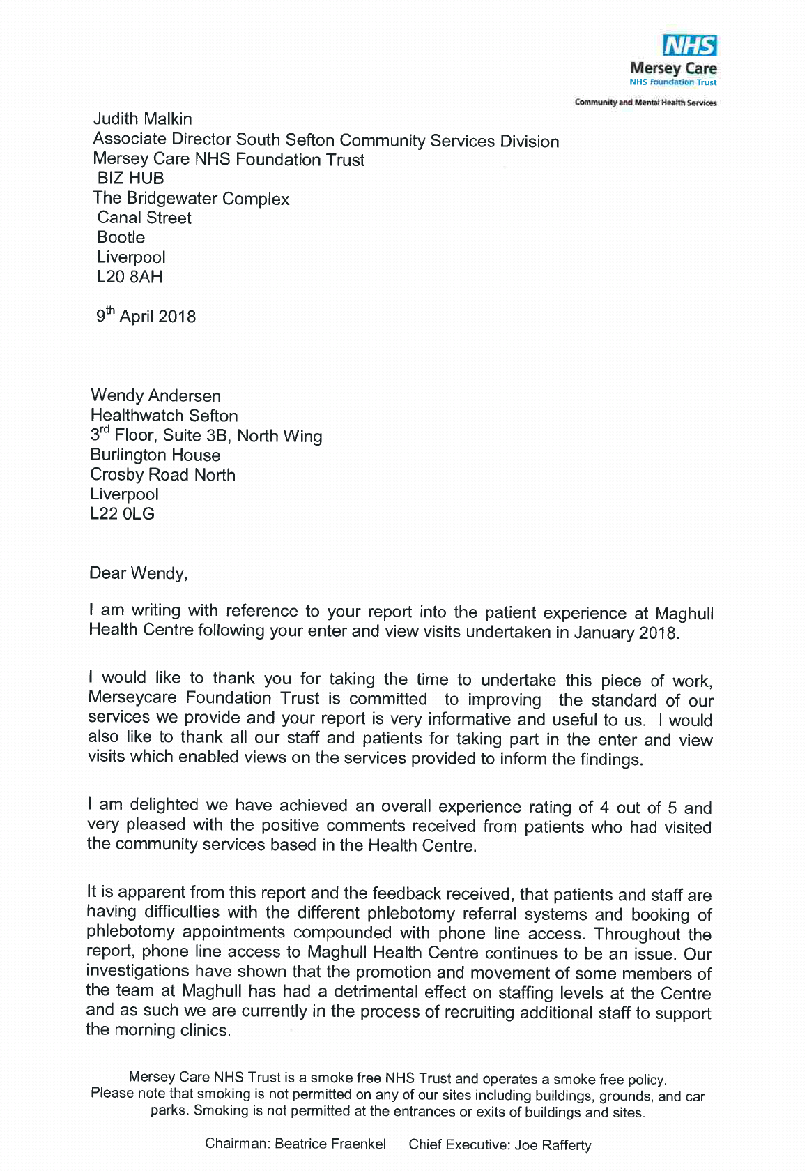

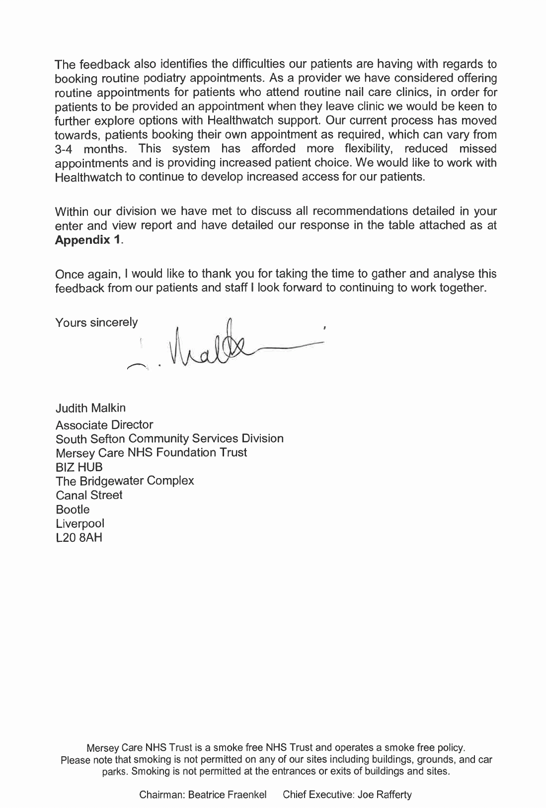

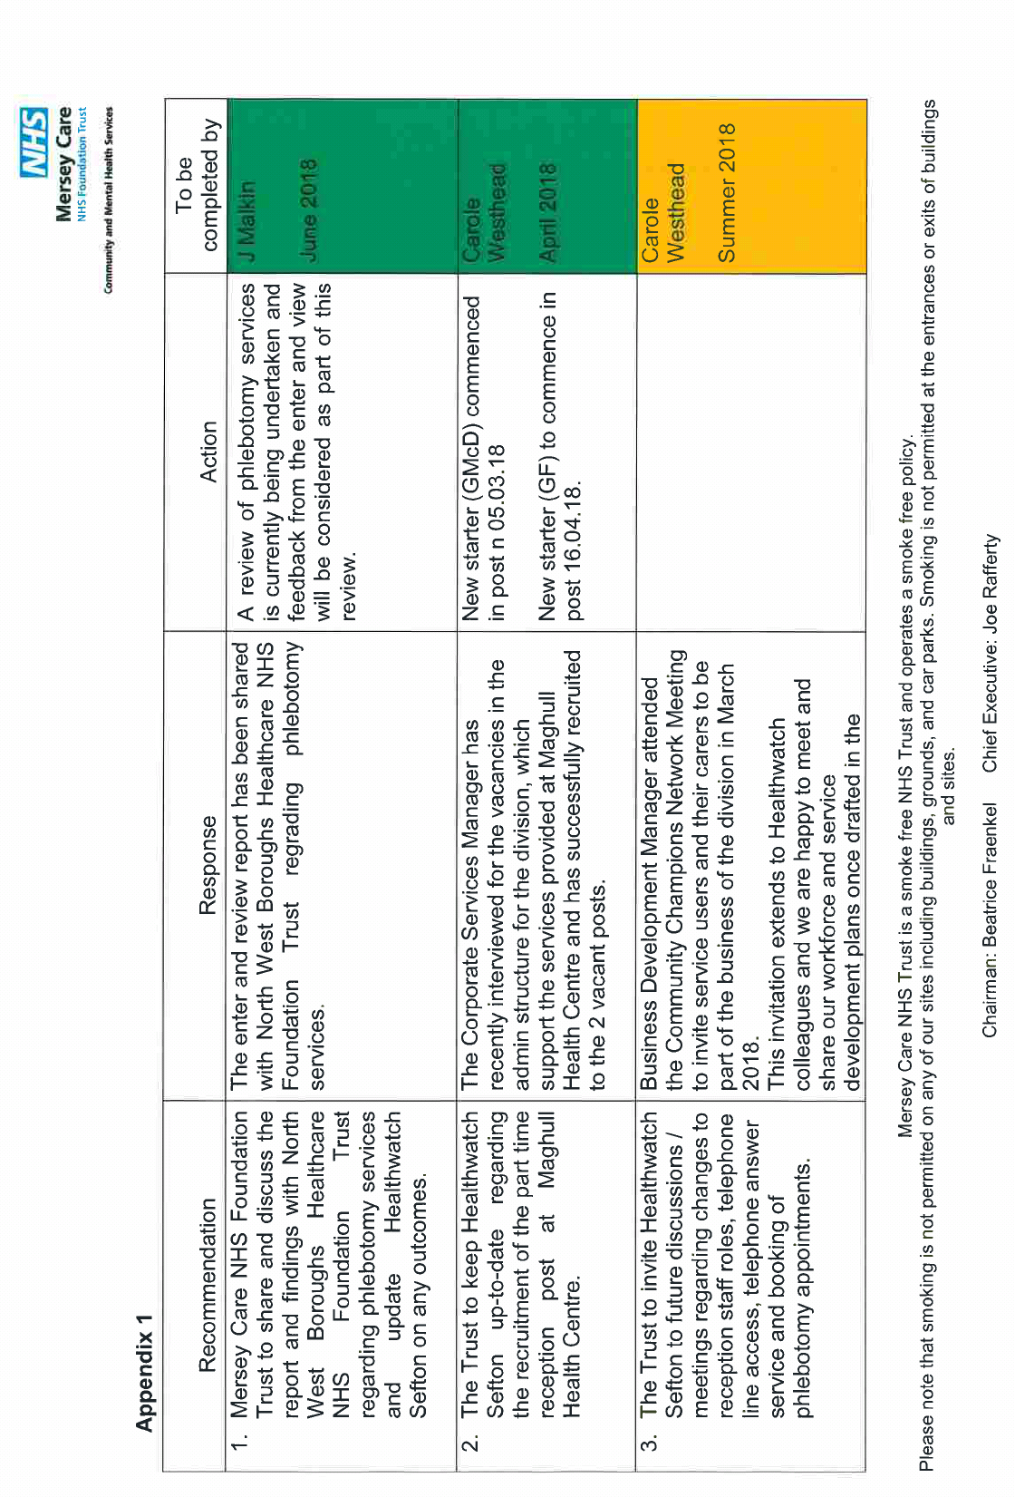

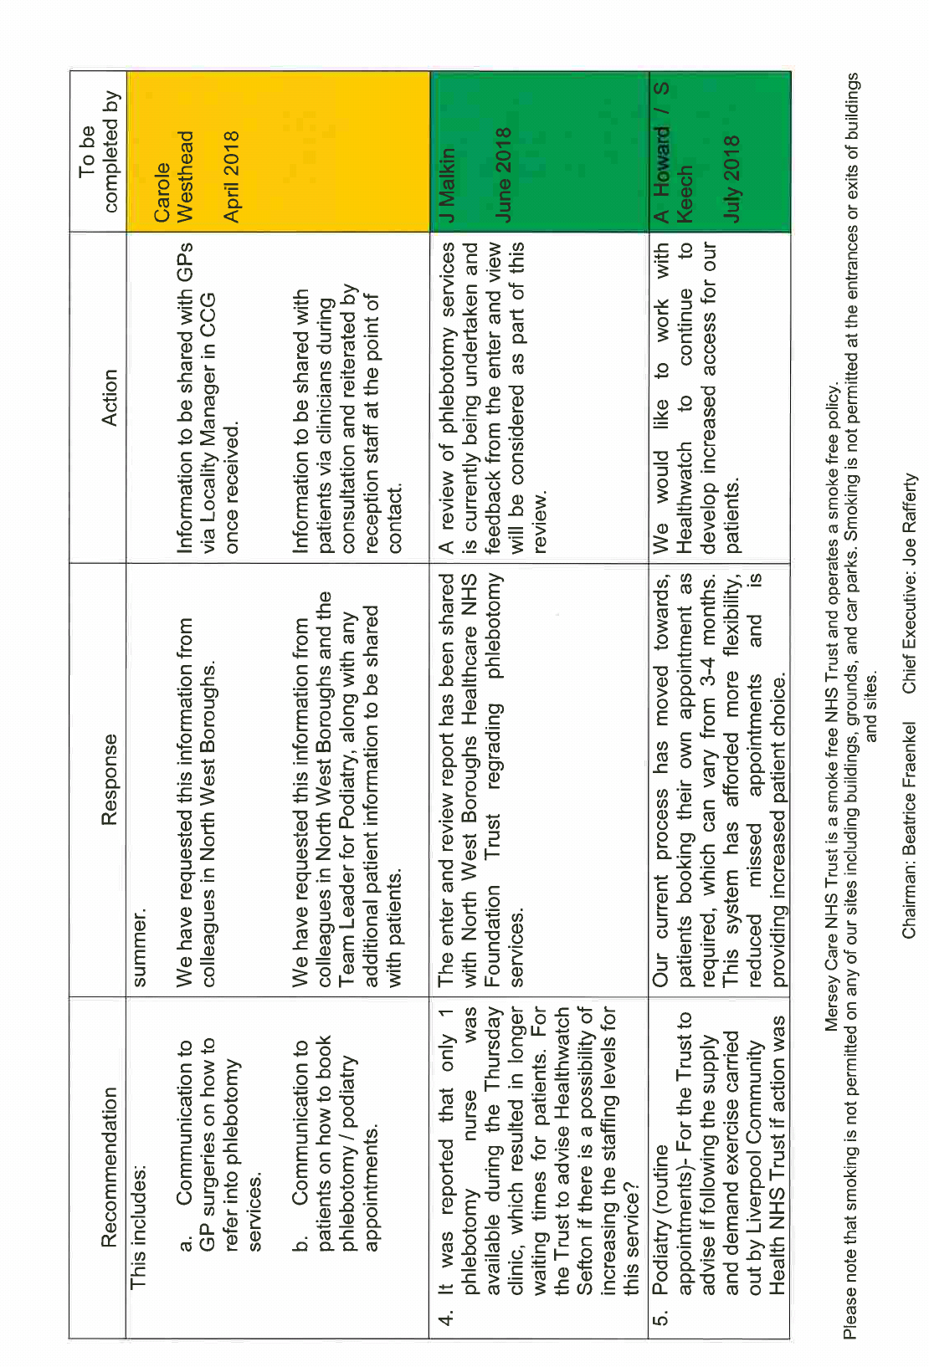

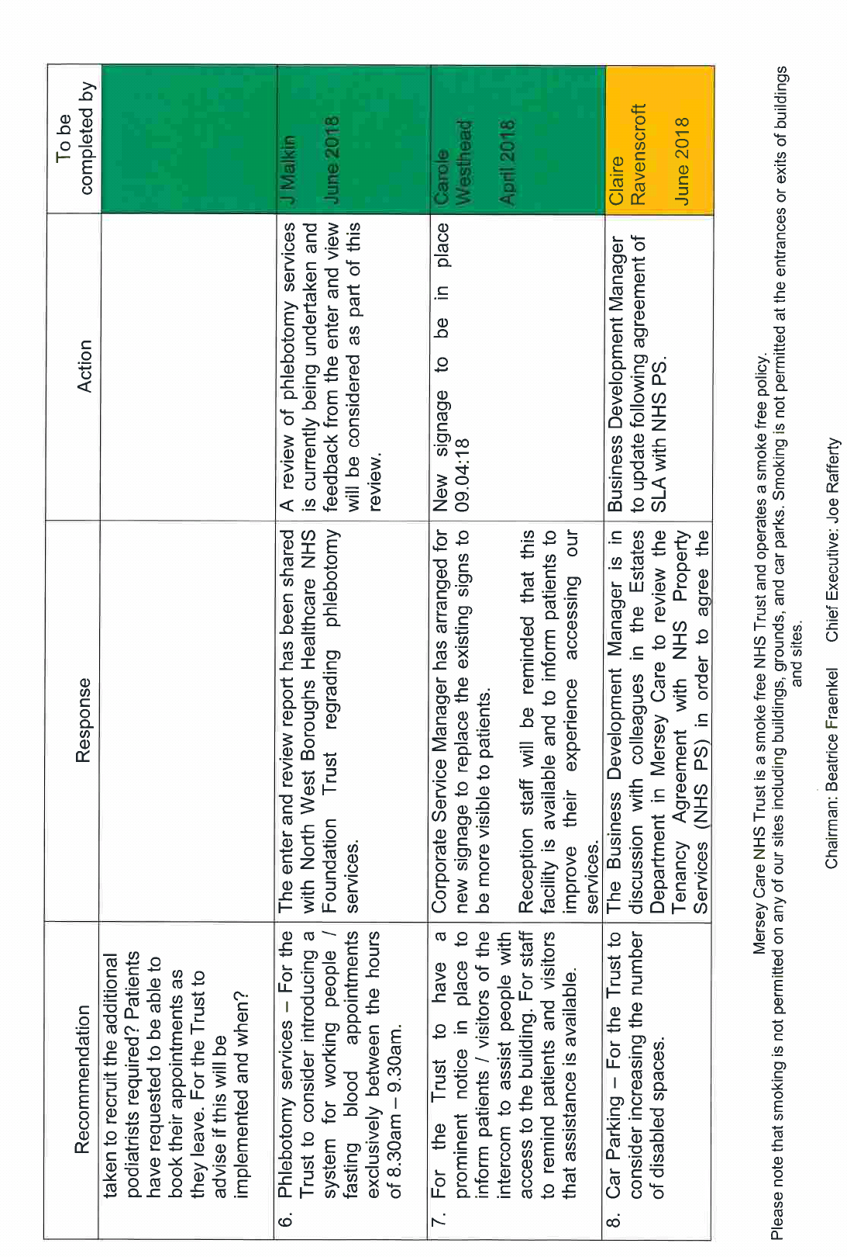

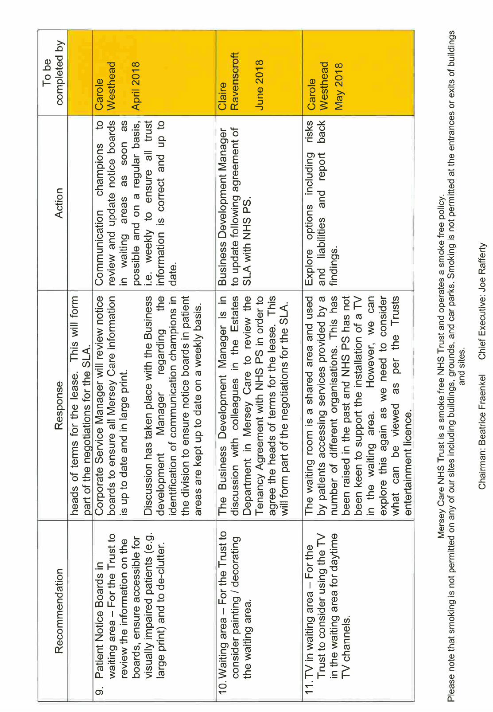

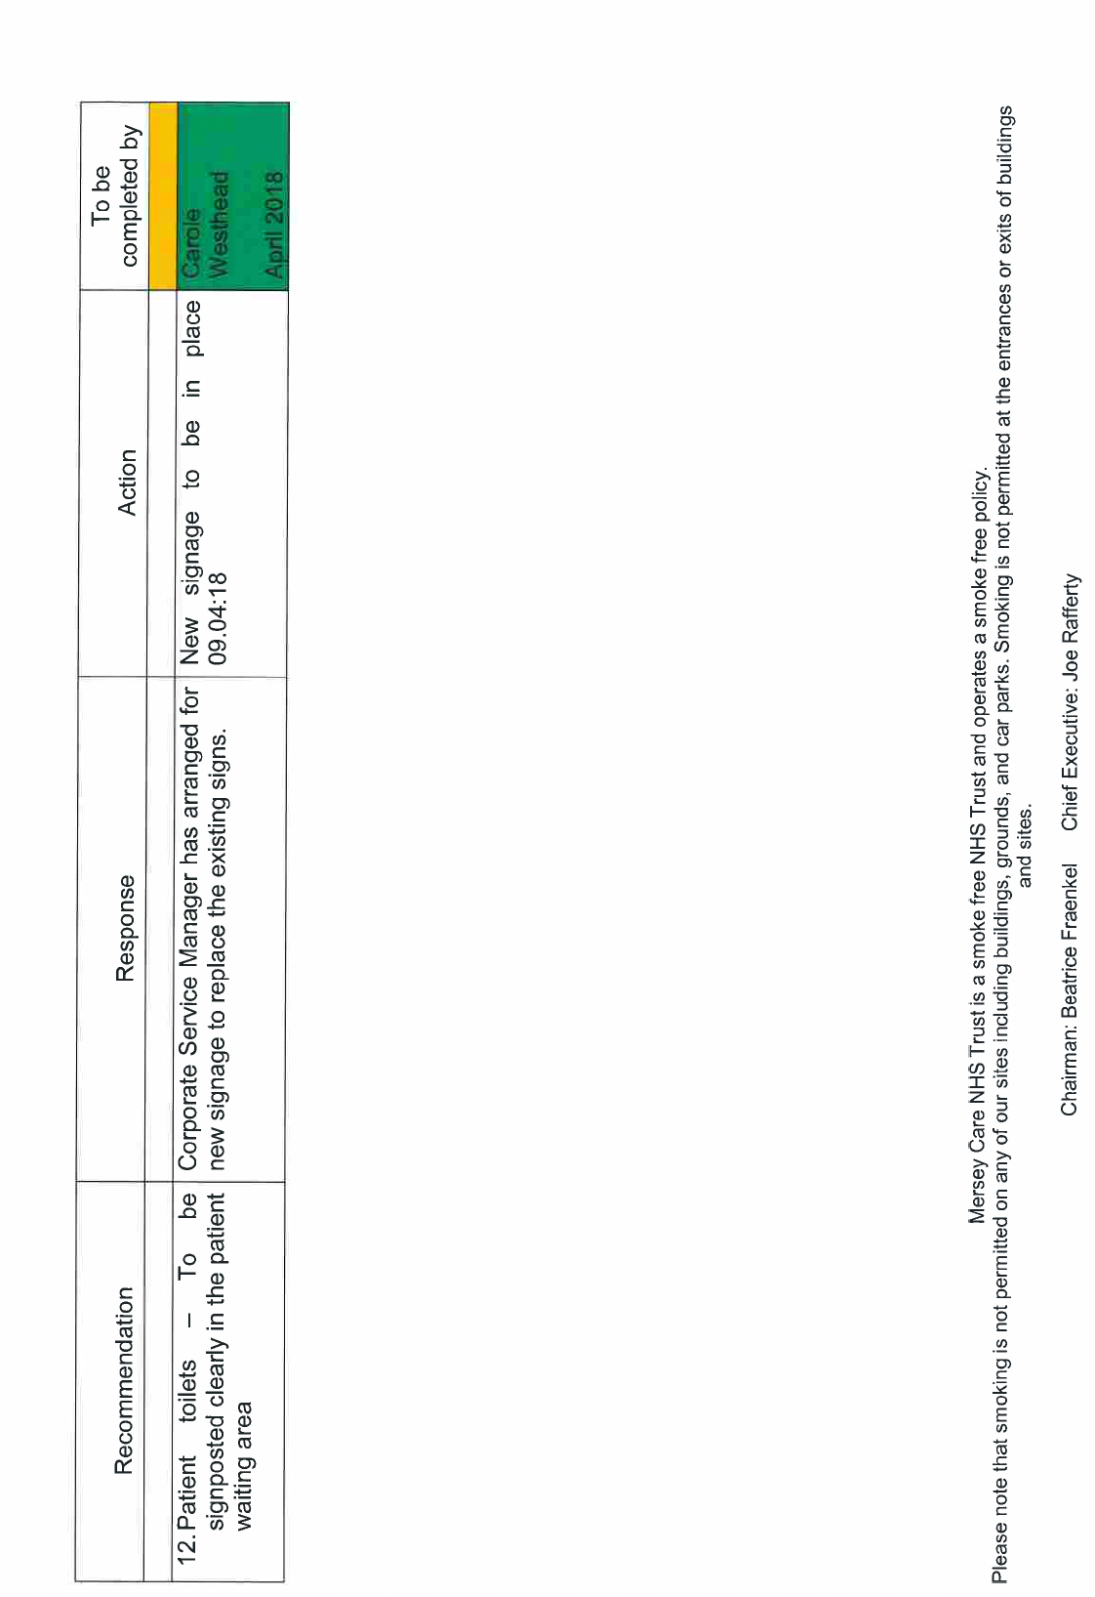

Feedback questionnaire
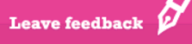

Please use our star rating system, where for example, a 1 star rating would be the worst/least agree, 3 would be a middle/medium rating, and 5 would be the best possible rating.
Approx. Date of Experience

How do you rate your overall experience of this service?

Summary of your experience (max 45 characters)

Tell us more about your experience*

Where do you live? (town/city)

Which department did you visit?

Your ratings (select if applicable)

Quality of treatment
Staff Attitude
Cleanliness
Quality of Food & Drink (if Applicable)
Communication
Discharge
Quality of Environment
Appointment (waiting times)
In relation to your comments are you a…
Patient/Carer/Friend/Staff Member/Other (describe)

Do you want to know more about how to make an official complaint?
Yes/No

About you
Name:
Address:
Email/Number if want to leave*
(Your email/number will be kept private and you will not be sent any marketing material)

Contact us

Address: Healthwatch Sefton, Sefton Council for Voluntary Service (Sefton CVS), 3rd Floor, Suite 3B, North Wing, Burlington House, Crosby Road North, Waterloo, Liverpool L22 0LG
Phone number: 0151 920 0726 (ext 240)
Freephone: 0800 206 1304
Text: 07434 810438
Email: info@healthwatchsefton.co.uk
Website: www.healthwatchsefton.co.uk


@HWatchSefton
@HWSFindServices


www.facebook.com/healthwatchsefton2013/

