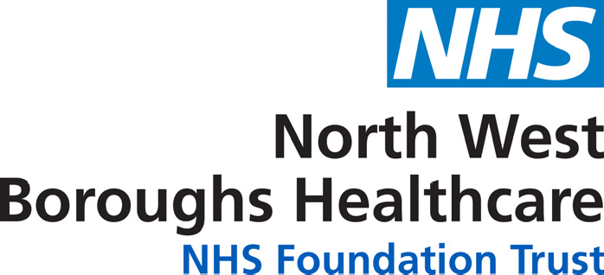
Have a voice Become a member

Have a voice in health - become a member today!

North West Boroughs Healthcare NHS Foundation Trust provides a range of community health, mental health and learning disability services, across Greater Manchester, Halton, Knowsley, Sefton, St Helens, Warrington and Wigan.

We want you to become a member of the Trust
As a Foundation Trust member you can help decide how your Trust should be run. Your views, suggestions and ideas will help us to shape our plans to deliver your future healthcare.

Membership can give you a voice in the decision-making process and provide an opportunity to play an active role in our development, it’s free to join and you can get involved as little or as much as you want.

There are many additional and valuable benefits too, such as receiving health advice, invitations to workshops and events, regular newsletters and volunteering opportunities. As a member of the Trust you can use the NHS discounts website to shop online, print out vouchers, get advice from confidential, free help line services and book holidays; all in the knowledge that you’ll be saving money. Visit the website at www.nhsdiscounts.com to register.

Just complete the form overleaf to join us and have a voice in shaping the services we provide.

Please note that you must be 14 years or older to become a member. For further information please visit our website at: www.nwbh.nhs.uk or contact the Foundation
Trust Office on 01925 664803.

Membership application form

Please return to Freepost RTKK-XUHS-HLAR, Membership Team, North West Boroughs Healthcare NHS Foundation Trust, Hollins Park House, Hollins Lane, Winwick, WA2 8WA

About you... Title:……………….. Full name:…………………………………………………...

Date of birth: …./…../….. Address: ……………….…………………………………………………...

……………………………………………………………………………….Postcode:…………………….

Tel:…………………....……….. Email:…………………………………………………………………….

Do you have a disability? Yes [ ] No [ ] Prefer not to say [ ]

If you answered yes, please indicate your disability and any special needs you have:

Sensory disability [ ] Physical disability [ ] Mental Health Problem [ ] Learning Disability [ ]

What is your sex? Male [ ] Female [ ] Prefer not to say [ ]

How would you describe your ethnicity?

White British [ ] White Irish [ ]
White Gypsy or Traveller [ ] White other [ ]
Mixed White & Black Caribbean [ ] Mixed White & Black African [ ]
Mixed White & Asian [ ] Mixed other [ ]
Asian or Asian British Indian [ ] Asian or Asian British Pakistani [ ]
Asian or Asian British Bangladeshi [ ] Asian or Asian British Chinese [ ]
Asian or Asian British Other [ ] Black or Black British African [ ]
Black or Black British Caribbean [ ] Black or Black British Other [ ]
Other Ethnic Group. Arab [ ] Other Ethnic Group [ ]
Prefer not to say [ ]

What is your sexual orientation?

Heterosexual / Lesbian [ ] Gay [ ] Bisexual [ ] Prefer not to say [ ]

What is your religion?

Christian [ ] No religion [ ] Islam [ ] Hinduism [ ] Buddhist [ ]
Jewish [ ] Sikh [ ] Prefer not to say [ ]

What is your marital status?

Single [ ] Married [ ] Co-habiting [ ] Divorced [ ] Widowed [ ] Prefer not to say [ ]

Level of engagement with the Trust

[ ] Active For example, receiving regular updates, invitations to workshops and events, information about being a Governor to sit on our Council of Governors and comment on services and plans.

[ ] Informed For example, taking part in surveys and commenting on services and plans

Declaration
I apply to become a member of North West Boroughs Healthcare NHS Foundation Trust and be bound by the rules of the organisation. I give consent to the processing of my information.

Signed: ………………………………………………………………. Date: …./….. /…...

Please tick the box if you do NOT want your name and constituency to be available to the public through the Foundation Trust register of members. [ ]

