This document is available in alternative formats on request
Healthwatch Sefton Expenses Policy

Members of Healthwatch Sefton, who are fulfilling their role as a representative of the organisation, are entitled to ‘out of pocket’ expenses. This is to reimburse costs to enable volunteering opportunities, participation in meetings, training events and other relevant events and not to reimburse their time, which they (or their organisation), give voluntarily. Any payments made by Healthwatch Sefton or by any other organisation, over and above reasonable out of pocket expenses may affect social security benefits received by members and may also require a declaration of interest. Any meetings/events/training attended must be with the prior consent of Healthwatch Sefton and the member must produce a report (using the Healthwatch Sefton template) following attendance within one calendar week unless there are mitigating circumstances which have been reported to the Healthwatch Sefton staff team.
Please note that it will only be possible to continue paying expenses for the duration of Healthwatch Sefton existence. Healthwatch Sefton has limited funds which must be prioritised towards individual members or those representatives whose organisations have limited incomes. It would be greatly appreciated if representatives from larger organisations were reimbursed through their organisations resources.
The following expenses have been agreed by the Healthwatch Sefton Board of Directors:
Travel.
Mileage Allowance – 45.0p a mile (or applicable).
Cycle Allowance - 20p per mile will be paid for any business related journey made by bike.
Public Transport – refund of full fare on production of tickets.
Taxis – these must be agreed and pre-booked via Healthwatch Sefton and used only where appropriate.

Consumables and miscellaneous costs.
We recognise that the quantity of documentation relating to Healthwatch Sefton matters can be significant! Although most reports and documentation will be produced via the staff team, paper for printing documents and papers for Healthwatch Sefton meetings can be provided with prior agreement. Where representatives are using their own, a contribution of 70% towards replacement cartridges and other miscellaneous costs can be paid. These payments will need to be agreed in advance with the staff team.
Carer/ Childcare costs.
Healthwatch Sefton is responsible for ensuring that members are able to access Healthwatch Sefton meetings and events. Responsibilities to care for a child or an adult can be a barrier to participation. Therefore, Carer and childcare costs can be reimbursed to ensure Carers can attend meetings. Lists of registered Care Providers and costs for reimbursement for registered Care Providers can be provided on request.
Subsistence.
Healthwatch Sefton members attending a full day event relating to the work of the organisation, where lunch is not provided, can claim subsistence allowance as follows:
Lunch – up to £5.00 / Dinner – up to £10.00
Other
Any claims that do not fall under the above will need to be cleared in advance with Healthwatch Sefton.
Claims for expenses must be accompanied by relevant receipts and claimed on a monthly basis (by the 5th of the month for the previous month) by using the appropriate expenses form. Forms can be requested from the staff team and a copy of the form can be found on page 4. BACS (Bankers Automated Clearing Service) payment scheme is the main method for reimbursement. Members will need to fill out the ‘Expenses Details’ form on page 3 and return this to Healthwatch.
Any queries regarding the payment of Healthwatch Sefton expenses should be raised in advance with the staff team.

Agreed: October 2018.
Review Date: October 2020.

This form is available in alternative formats on request.
Expenses Claim Sheet

Claims will be paid either at the rate of 40p per mile for car users, 20p per mile (cycle allowance) or the equivalent Public Transport rate. Please attach any bus/train tickets/receipts for Car Parking.

Date | Reason for Travel & Destination | Mileage/Bus/  Train | Other Expenses (Detail) | Total
 |  |  | Grand Total
Name and Address of Claimant:  Signed : |  |  | Authorised by Healthwatch Sefton Staff Team:  Signature:  Date:

Healthwatch Sefton Volunteer: Expenses Details.

Please supply the following information so expenses can be paid directly into your bank account.

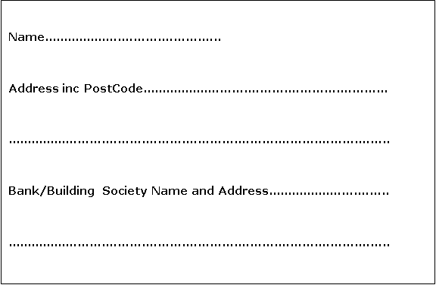

• Any Claim for expenses must be submitted by the 5th of the month for the previous month. E.g. Expenses claims for January must be submitted by 5th February.
• Payments will only be authorised if receipts are provided.
• Expenses are capped at a limit of £25 per month.
• Please speak to the Healthwatch Sefton Manager before going over the £25 limit, and have this agreed prior to any overspend.

