


South & Central Community Champion Network Meeting
22nd January 2019
Themed network meeting – Review of urgent healthcare in south Sefton
Held at: Sefton Carers, Waterloo.

Chair
Wendy Andersen (WA) Healthwatch Engagement Manager

Attendee
Barbara Rouse (BR) Bootle YMCA / Bootle Action group
Joanne English (JE) People First Merseyside
Emma Grange (EG) People First Merseyside
Lesley Curran (LC) People First Merseyside
Simon Walker (SW) People First Merseyside
Rachael Roy (RR) People First Merseyside
Clare Johnston (CJ) Sefton Carers Centre
Sandra Bell (SB) Reach Mens Centre
Margi Roberts (MR) Kids Konnect
John Battersby (JB) Sefton Advocacy
Sarah Oldnall (SO) Bootle Locality Representative
Diane Foulston (DF) Crosby Locality Representative
Maurice Byrne (MB) Maghull Locality Representative
David Lloyd (DL) Netherton Locality Representative
Brian Clark (BC) Southport North Locality Representative
Anne Major (AM) Central Southport Locality Representative
Nigel Booth (NB) Formby Locality Representative
Derek Thomas (DT) Visually Impaired group

Healthwatch staff member(s)
Betty Boner Healthwatch Engagement & Participation Officer

Speakers / support team
Janet Spallen (JS) NHS South Sefton CCG
Joanne Herndlhofer (JH) NHS South Sefton CCG
Laura Gibson (LG) NHS South Sefton CCG
Becky Kelly (BK) NHS South Sefton CCG

Apologies
Monica Wright (MW) Caradoc Mission Kids
Justine Shenton (JS) Sefton Older Person’s forum
Chris Dale (CD) Age Concern Crosby

- Apologies / Introductions

WA welcomed all members and guest speakers to Sefton Carers Centre. Members and speakers were asked to introduce themselves. Apologies were noted.

Welcome to Review of urgent care healthcare in south Sefton

WA informed members that today’s meeting was themed on the review of ‘urgent healthcare in south Sefton’ and introduced the guest speakers from the CCG.

Code of Conduct / Declarations of Interest

All members to abide by the Code of Conduct and declare any Declarations of Interest.

Inclusivity of members

Reminder: To ensure meetings are inclusive of all members. Members and guest speakers to ensure:

- No jargon, abbreviations or big words to be used during meetings.
- Presentations and resources that are handed out to be available on the day in a size 16 font. Guest speakers are informed of this prior to all meetings.

- Review of urgent healthcare in south Sefton

Both Janet Spallen (JS) and Jo Herndlhofer (JH) presented information relating to the review of urgent healthcare in south Sefton. This included:

- Overview of the session (what today’s session would include)
- Why they are undertaking the review
- What the review will look at in south Sefton
- The engagement approach and activities
- How they are involving people
- Group work during the session

Both JS and JH stated it was also important to have the input from residents who live in the north of Sefton as they at times also use the services within south Sefton including the Walk-in Centre. BB asked if this review would take place in the north at a later date. JS stated that due to the review taking place at Southport hospital it was decided not to conduct the review of urgent healthcare at this time. JH said that this would take place at a later date.

During the group work members were asked to consider 4 questions when considering urgent care services for adults, children and mental health in south Sefton:

- Where do people go and why?
- What influences their choices?
- What does good look like?
- What are the current gaps and barriers?

The full presentation on the review of urgent healthcare in south Sefton is attached.

- Agreeing notes and review outstanding actions.

The notes from the meeting held on Tuesday 20th November 2018 were previously circulated to all members for comments or amendments and were today agreed as accurate at the meeting.

Outstanding actions following the November 2018 meeting include:

- Specsavers – audiology services – MB confirmed Specsavers was now offering home visits for both audiology and eye sight test. Healthwatch Sefton will approach Aintree hospital to see if they will offer their support group sessions to Specsavers clients? Update: the Trust has confirmed all additional support services are available to all patients including patients who attend Specsavers.
- Medicines Management – WA to share contact details between JE and Susanne Lynch re: taking forward an issue on behalf of LC. Action: completed
- Review of urgent healthcare in south Sefton to be included at the community champion network meeting. Action: completed.

- Previous emerging issues / questions taken forward to Healthwatch Steering group.

- No issues or questions taken forward from the November 2018 meeting.

- Healthwatch Sefton & Locality Rep updates. For comment only.

A Healthwatch Sefton written update has been circulated to network members, this included an update on PPG’s (Patient Participation Group’s), GP Access and Maghull Health Centre Action: update previously circulated to members and attached.

JB asked about PPG’s and how the GP surgery can be told to have one in place. This was in reference to his own GP surgery within the Crosby locality. WA explained that the role of Healthwatch is to raise awareness and encourage GP practices to develop a PPG. Healthwatch will meet with the CCG on the 30th January 2019 to progress this area of work. DF stated that she has visited 4 of the GP practices within the Crosby area and that she intends to visit the remaining GP surgeries within the Crosby locality by spring.

- Moving forward

WA informed members that themed Community Champion meetings were previously discussed during 2018 with the first themed meeting being held last year re: PPG’s. Members felt moving forward themed meetings were productive and informative and felt it would be more beneficial to the group and the community to continue and progress with this. Healthwatch Locality Representatives had also discussed this at the Locality Representative meeting held on 21st January and felt this was a positive move forward stating this would ensure the Community Champion meetings were not duplicating work of the Healthwatch Steering group and provided more of a focus for the champion network.

WA stated that there had been issues / comments raised by both Community Champion members and individuals re: ‘GP extended access service’ and asked members if they felt this was a topic they would like to have covered for the next meeting. WA also stated that the Southport & Formby Community Champion network were holding their next meeting on this topic.

It was agreed by members for this to be the next themed community champion network meeting. WA to organise guest speakers from:
- The provider of the service ‘GP extended access’
- NHS south Sefton CCG
- A GP Practice Manager

JE asked if People First would be able to show a short film at the end of this meeting re: The Red Flag project. This was welcomed by all members at the meeting.

Action: WA to share the date of the next meeting once guest speakers have been confirmed. JE to arrange for the Red Flag Film to be shown at the meeting.

Another key theme that has been raised and discussed at both the south and central Community Champion network meetings along with the Southport & Formby Community Champion network is ‘podiatry’. On a regular basis Claire Ravenscroft, from Mersey Care NHS Foundation Trust has attended each meeting to provide updates on community services including podiatry services.

Lancashire Care NHS Foundation Trust provides community services including podiatry services for the Southport and Formby localities. Lancashire Care has informed Healthwatch on how they are moving forward by working more closely with Mersey Care in relation to the podiatry service and has offered to provide a joint update from both Trust’s at a future Community Champion meeting. Members agreed that this would be beneficial to be a planned Community Champion meeting and requested that each Trust also provide a list of all the community services that they provide. Action: WA to work with Betty Boner to organise a joint Community Champion meeting re: podiatry services.

- Information exchange/ Any Other Business.

- Members to forward any information to be shared to WA.

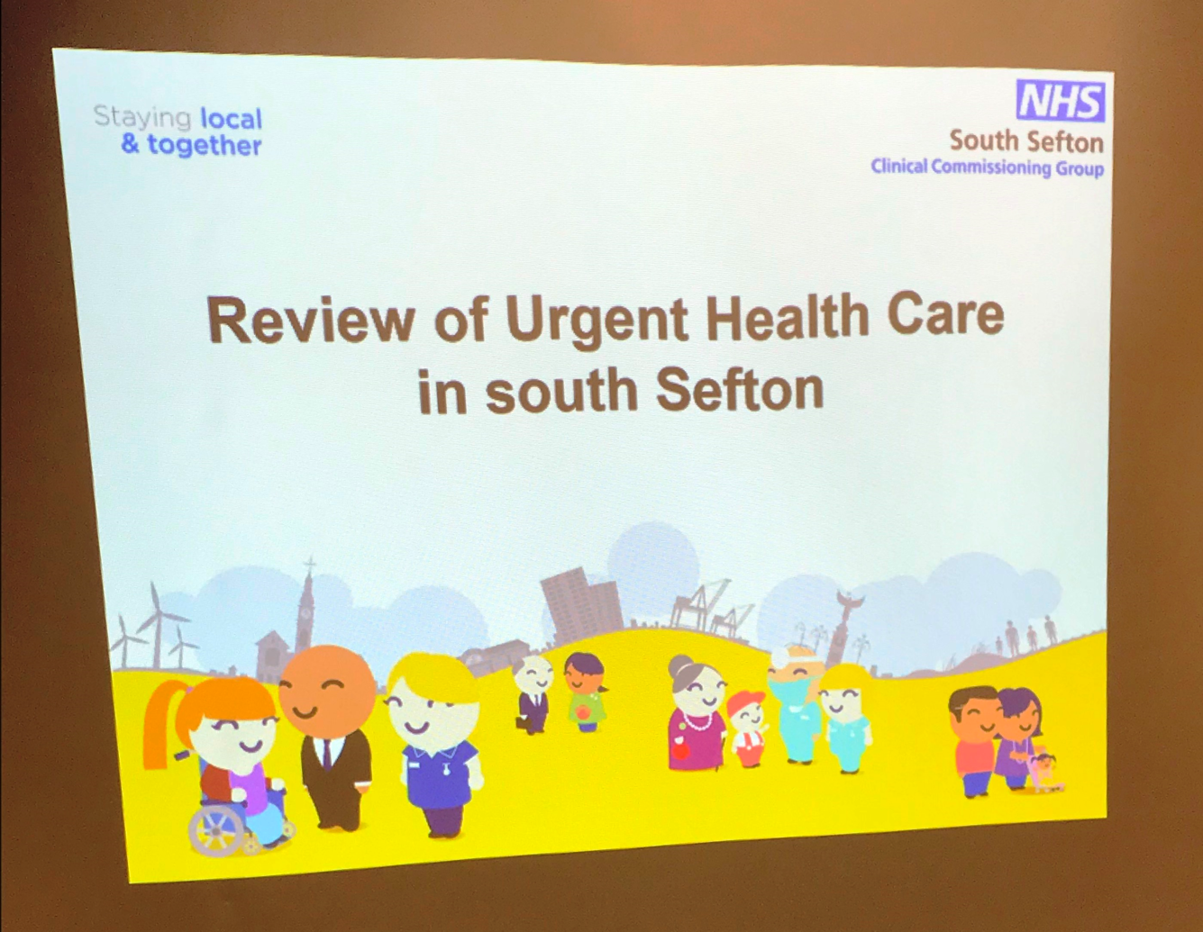
Date and Time of Next Meeting:

TBC

