Understanding how people with a learning disability and autistic people feel about waiting for elective care
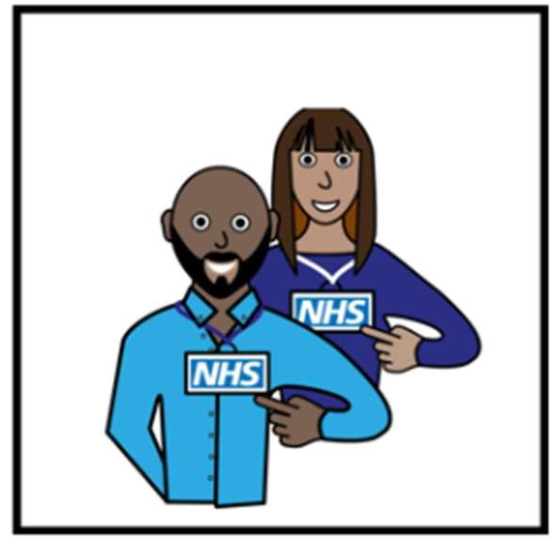
NHS England (with some help from the Improvement Unit) are doing some research



Research is when we ask people questions to find things out

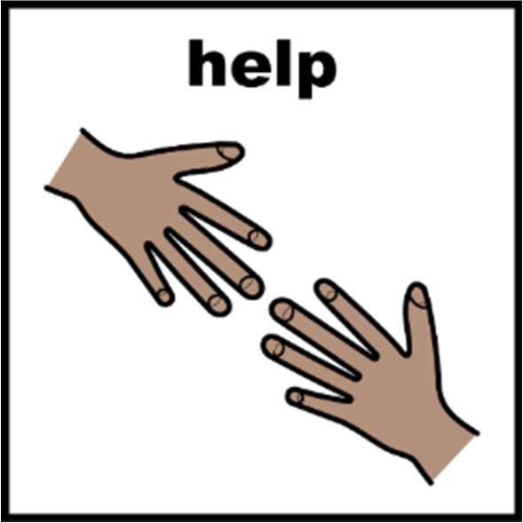
We would like your help

All Images/Resources copyright © LYPFT

We would like to know what you think about waiting for an elective care hospital appointment

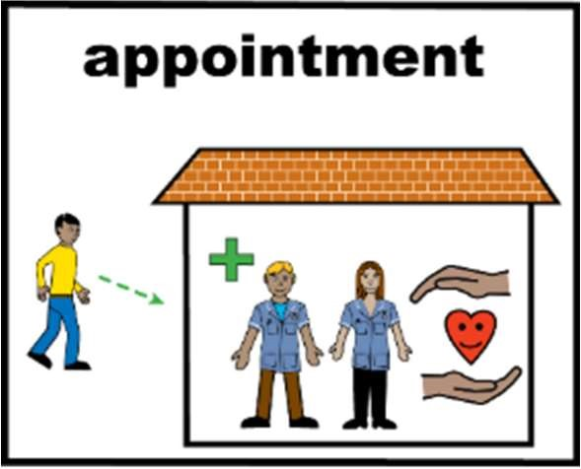
Elective care includes planned, nonemergency care such as tests, surgery or treatment


We will use this information to understand what is important to you

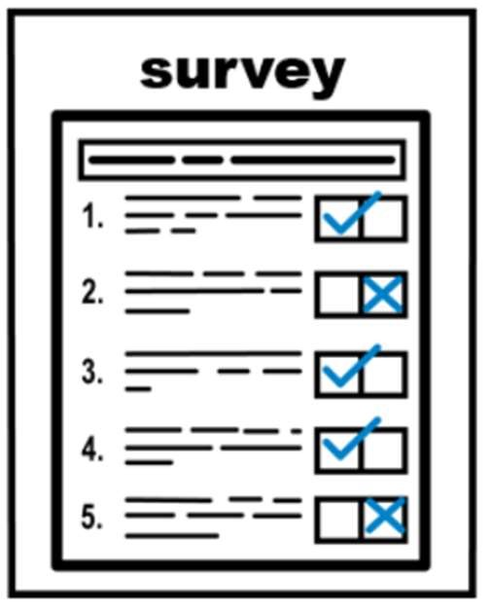
We are sharing a survey so different people can share their views

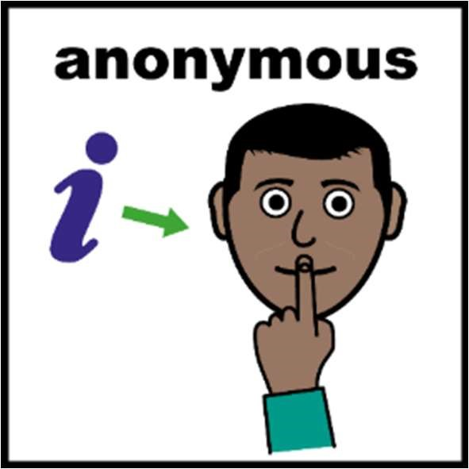
The information you share is anonymous

Anonymous is when we do not know who said it

 You can fill the survey in on your own

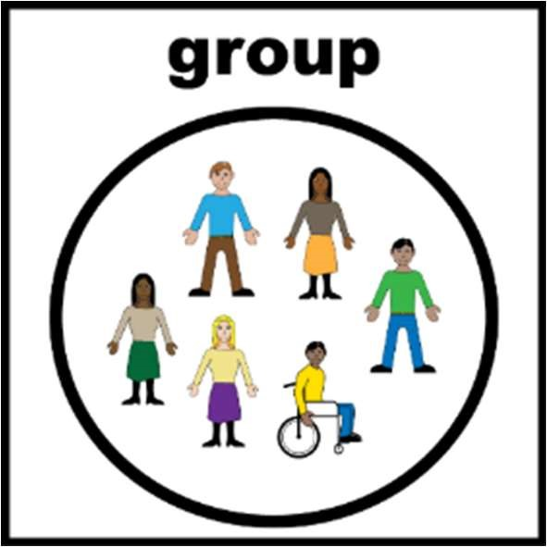 Or you can fill it in as a group


We will look at all the information people

tell us in the survey
 This will help us understand a few things:

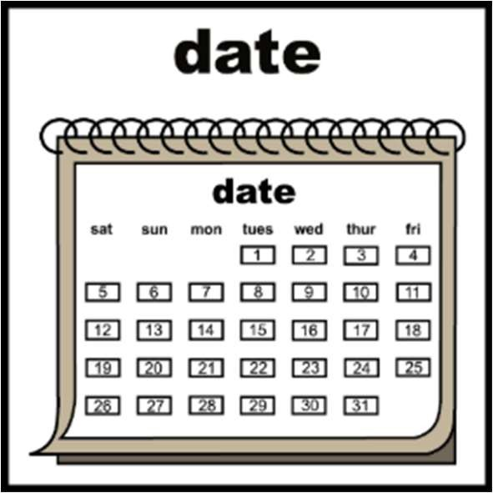
What is important to people with a learning disability and autistic people about waiting for elective care

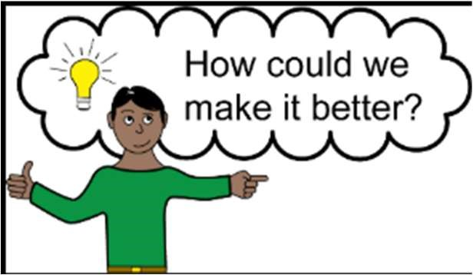
How waiting for elective care could be improved


We want to talk to you because you have a learning disability and / or are an autistic person and live in the North West of

England
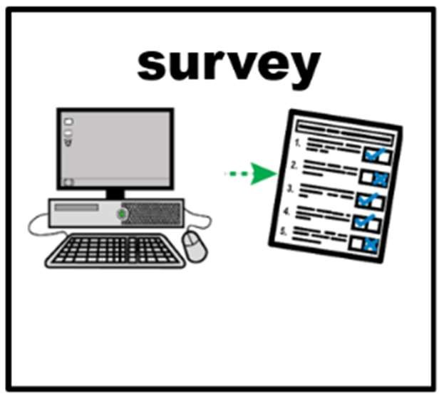
If you agree to take part:

Complete the survey online

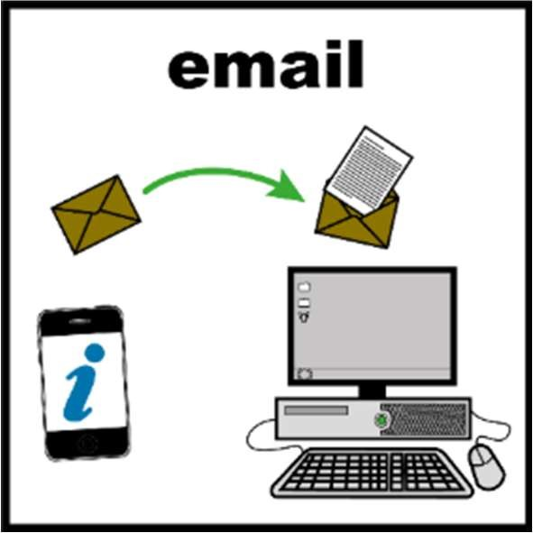
You can contact
mlcsu.improvement@nhs.net if you need support in completing the survey


If you do not want to take part do not complete the survey

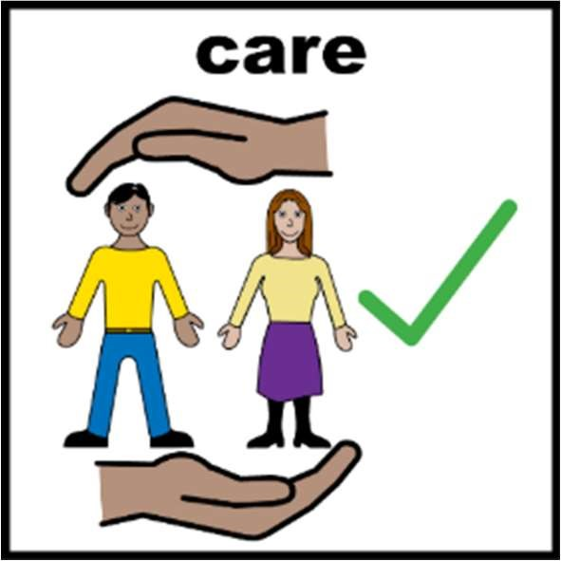
If you do not want to take part it will not change the care you get

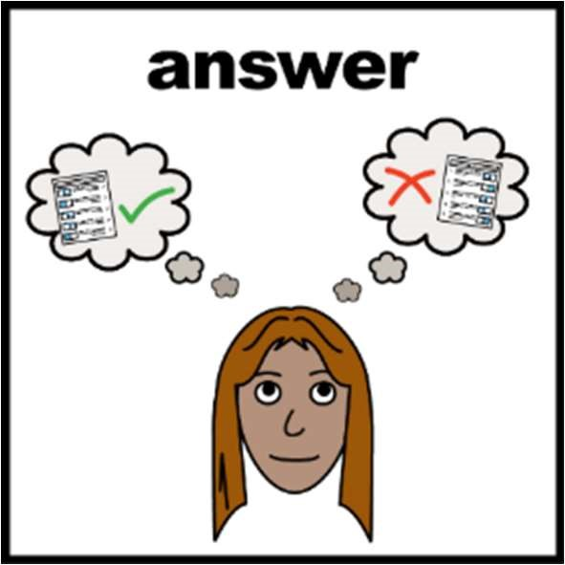
You can change your answers to the survey before the survey deadline ends

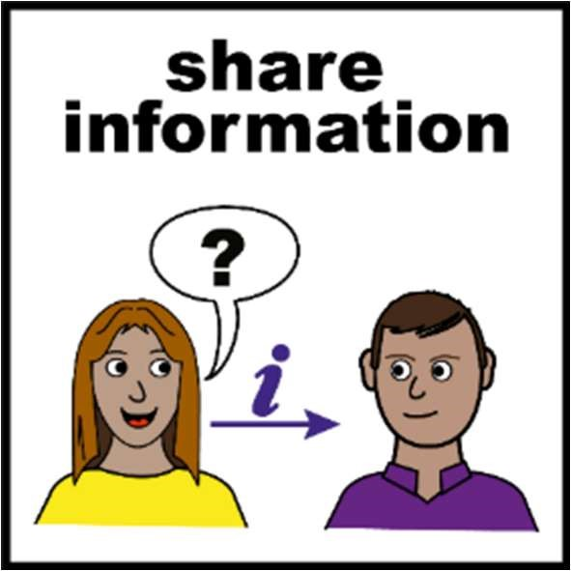
We will share what we find out from the survey with groups across the North West

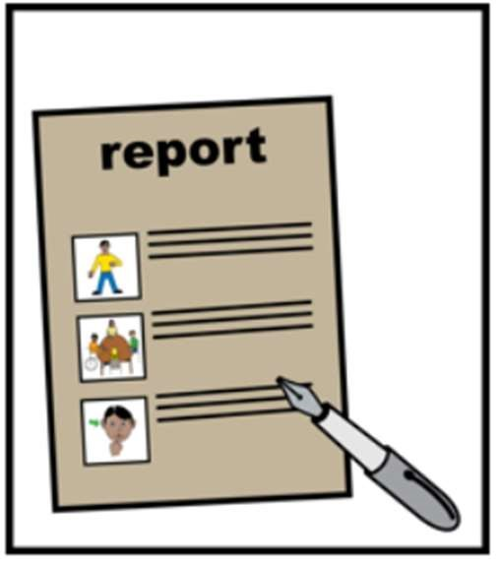
We will also put what we find out into a report

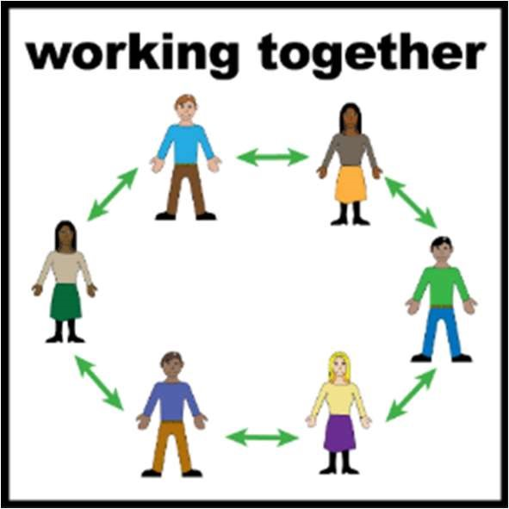

The findings and report will be shared with lots of people including hospitals This will help other people know what is important to people with a learning disability and autistic people


It will also help them to make improvements to waiting for elective care

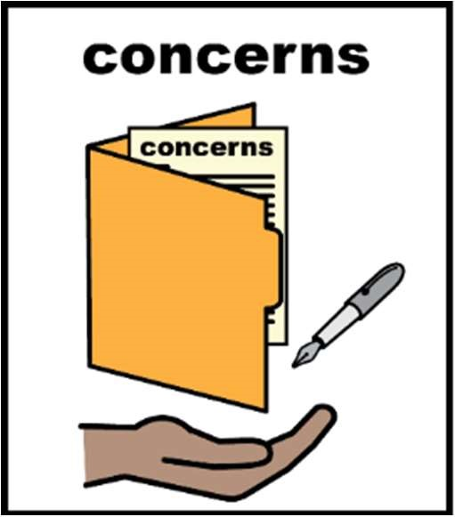
If you have a concern around how your information is being used email: mlcsu.dpo@nhs.net

 Thank you for sharing your views

